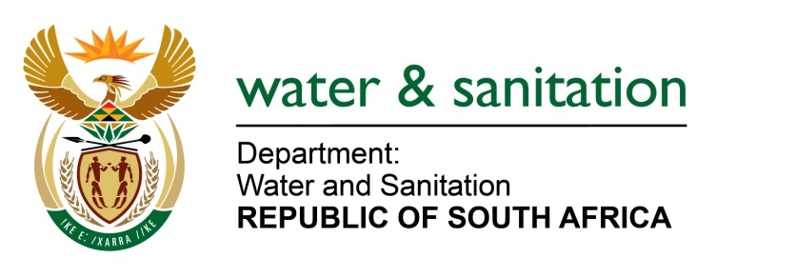

NATIONAL ASSEMBLY

FOR WRITTEN REPLY

QUESTION NO 51

DATE OF PUBLICATION IN INTERNAL QUESTION PAPER: 8 FEBRUARY 2018
(INTERNAL QUESTION PAPER NO. 1)

51. Mr L J Basson (DA) to ask the Minister of Water and Sanitation:
By what date will a new board for the Mhlathuze Water Board be appointed? NW56E

---00O00---
REPLY:

My Department has commenced with processes to appoint a new Board of Mhlathuze Water Board. A submission for the appointment of a selection panel and a chairperson to consider all nominations received and make recommendations on Board appointments was completed. It is anticipated that the selection panel will commence and conclude its task by March 2018 and it is expected that the new Board will be appointed in April/May 2018, as it requires Cabinet concurrence.

---00O00---

