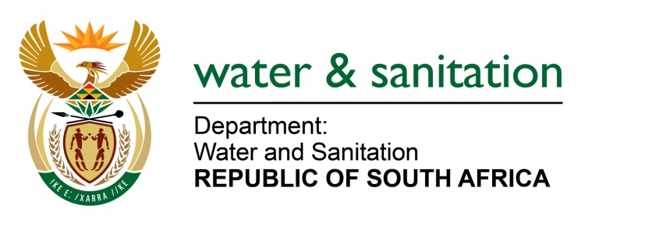

NATIONAL ASSEMBLY

FOR WRITTEN REPLY

QUESTION NO 508

DATE OF PUBLICATION IN INTERNAL QUESTION PAPER:
(INTERNAL QUESTION PAPER NO. 4) 24 FEBRUARY 2023

508. Mr B N Herron (Good) to ask the Minister of Water and Sanitation:

(1) What are the most recent details of the (a) progress of the Umzimvubu Water Project located in the Eastern Cape and (b) timeline the project is following and (c) measures his department has taken to ensure community collaboration and input on the project;

(2) what number of (a) communities will be supplied with (i) electricity and (ii) clean water by the project and (b) projected economic opportunities in the form of jobs is the project expected to create;

(3) whether there are any geographical and/or environmental flaws like soil sedimentation and/or rainfall issues facing the project; if not, what is the position in this regard; if so, what are the relevant details?

NW553E
---00O00---

MINISTER OF WATER AND SANITATION

1. (a) Delays in implementation of Stage 2 to 4 of the project were due to funding constraints. Consequently, the Department explored alternative options for implementation through an RFI process. Prior to the finalisation of this process, engagements between the Department and National Treasury resulted in a decision to fund the project through direct funding from the fiscus as this was a more feasible option. The project has also been streamlined to make it more affordable.

(b) Stage 1 is scheduled for completion in June 2023 and construction of Stage 2 is scheduled to commence in the fourth quarter of the 2023/24 financial year.

(c) The Project Oversight Committees and the Project Liaison Committee have been established as part of social facilitation. The Community structures’ meetings are taking place as and when required. The workshops on the tendering process for local Small Medium and Micro Enterprises (SMMEs) was held on 13th and 14th July 2022.

2. (a) (i) The hydropower element of the project has been allocated to a later stage. DWS is currently negotiating with Eskom regarding Eskom’s possible involvement in the hydropower project.

(ii) 726 616 people will benefit from clean water

(b) An estimated 7070 direct and indirect employment opportunities per year will be created through the implementation of this project.

3. Inclement weather caused delays in the completion of Stage 1 of the project. Geographical and/or environmental challenges that may impact on Stage 2 of the project have not yet been determined.

---00O00---

