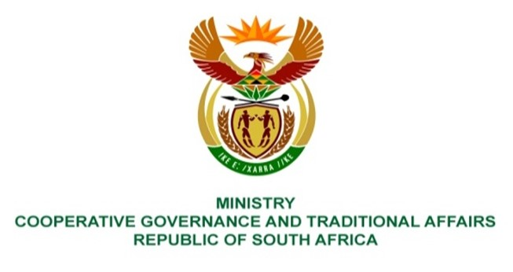

NATIONAL ASSEMBLY
QUESTION FOR WRITTEN REPLY

QUESTION NUMBER 505

505. Ms S A Buthelezi (IFP) to ask the Minister of Cooperative Governance and Traditional Affairs:
Whether, with the recent heavy rains that have once again wreaked havoc, damaging infrastructure, roads, and homes across the Republic and at least four persons having been swept away by overflowing rivers in Gauteng, while at least four lives were claimed by floods in Mpumalanga since the rains began, her department has ensured that all municipalities have disaster management plans in place; if not, why not; if so, what are the relevant details of her department’s involvement in the implementation of the plans? NW550E

REPLY:
- The Act in Sections 52 and 53 respectively, places explicit responsibility on all organs of state as well as all municipalities across the Republic for the development and implementation of disaster management plans. It is a legislative requirement that once developed, these plans must be submitted to the NDMC. The Minister of Cooperative Governance and Traditional Affairs (COGTA) through the NDMC within the Department of Cooperative Governance (DCOG) does all that she can to ensure that all municipalities have disaster management plans in place. The table below depicts the status on disaster management plans submitted to the NDMC by the Metros, Districts and local municipalities, to date:

TYPE OF MUNICIPALITY | NUMBER OF DM PLANS SUBMITTED. | NUMBER OF DM PLANS STILL NOT SUBMITTED
Metros | 7 | 1
District | 40 | 4
Local | 68 | 137
TOTAL: 115 |  | 142
- On receipt of the disaster management plans from municipalities, the NDMC performs an assessment to ensure compliance and the practicality of their implementation within the respective areas of their municipal jurisdiction. Frequently, the assessments reveal that most, if not all the plans assessed, were developed long before the guidelines on the “development and structure of a disaster management plan” were developed and published in 2017. The NDMC in its 2022/23 financial year Operational Plan, implemented jointly with the PDMCs, a project on stakeholder consultative workshops on the development and implementation of disaster management plans and guidelines on the integration of DRR measures into municipal IDPs in all 9 provinces. These workshops included sourcing of inputs from stakeholders to enhance the process to develop the Support Plan on the development and implementation of risk-informed disaster management plans by municipalities. Once approved by the Head of the NDMC, the guideline and the Support Plan will in the new financial year (2023/24) be piloted in 2 municipalities. These sessions also included a segment on Impact-Based Early Warnings to educate and remind all provincial stakeholders on the need to understand the different warnings levels and what should be done once the warnings are issued. It is about “Early Warning, Early Action” to safeguard lives and livelihoods within communities.
The NDMC continues to execute its legislative obligations by facilitating the promotion of an integrated and coordinated system of disaster management among national, provincial and local government, statutory functionaries and other role players involved in disaster management.
End.

