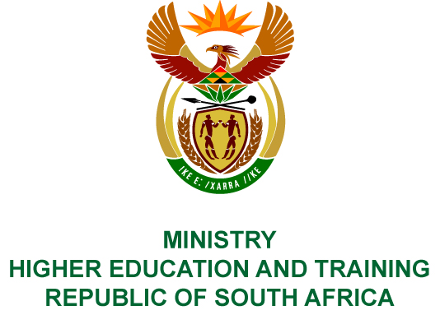
Private Bag X893, Pretoria, 0001, Tel: 012 312 5555, Fax: 012 323 5618
Private Bag X9192, Cape Town, 8000, Tel: 021 469 5150, Fax: 021 465 7956
MEMORANDUM FROM THE PARLIAMENTARY OFFICE
NATIONAL ASSEMBLY
FOR WRITTEN REPLY
QUESTION 501
DATE OF PUBLICATION OF INTERNAL QUESTION PAPER: 01/03/2019
INTERNAL QUESTION PAPER NO 05 OF 2019
Adv T E Mulaudzi (EFF) to ask the Minister of Higher Education and Training:
What is the total number of (a) plumbers, (b) electricians, (c) welders, (d) carpenters, (e) boiler makers and (f) mechanics who graduated from each institution of higher learning in the country in the 2018 academic year?
NW566E
REPLY:
The first phase of training artisans involves an integrated learning process of obtaining fundamental and practical training at a Technical and Vocational Education and Training (TVET) college. The second phase covers the trade theory including workplace training at an accredited workplace. The final phase is taking a National Trade Test in the relevant trade. The table below indicates the training that has taken place from 01 April 2018 to 31 December 2018:
Plumbers | Electricians | Welders | Carpenters | Boilermakers | Mechanics
715 | 2 291 | 651 | 102 | 703 | 2 262
Candidates are given three chances to pass the trade test. If they are still unsuccessful, they are placed on the Artisan Recognition of Prior Learning programme, which will assist them in obtaining their trade qualification.
The knowledge components for the trades are currently provided through the Report 191 qualification at N2 level and National Certificate Vocational (NCV) level three on the National Qualification Framework.
The table below indicates the number of students who passed the theory component of the trades through the Report 191 and NCV qualifications in the November 2018 national examination.
Trade Test | Passed
Plumber’s Theory N2 | 402
Plumbing L3 | 940
Electrical Trade Theory N2 | 3 147
Electrical Systems and Construction L3 | 5 288
Welder’s Theory N2 | 77
Welding L3 | 564
Plater’s Theory N2 | 685
Engineering Fabrication: Boiler making L3 | 1 054
Carpentry Theory N2 | 161
Carpentry and Roof Work L3 | 958
Motor Trade Theory N2 | 435
Automotive Repairs and Maintenance L3 | 1 816
Grand Total | 15 527

COMPILER DETAILS
NAME AND SURNAME: MR JABU NTSHINGILA AND MR JAMES MOGALE
CONTACT: 087 236 9324 / 012 312 6205
RECOMMENDATION
It is recommended that the Minister signs Parliamentary Reply 501.

MR GF QONDE
DIRECTOR–GENERAL: HIGHER EDUCATION AND TRAINING
DATE:

PARLIAMENTARY REPLY 501 IS APPROVED / NOT APPROVED / AMENDED.
COMMENT/S

MRS GNM PANDOR, MP
MINISTER OF HIGHER EDUCATION AND TRAINING
DATE:

