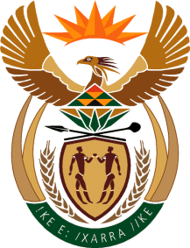

MINISTER OF TOURISM
REPUBLIC OF SOUTH AFRICA

Private Bag X424, Pretoria, 0001, South Africa. Tel. (+27 12) 444 6780, Fax (+27 12) 444 7027
Private Bag X9154, Cape Town, 8000, South Africa. Tel. (+27 21) 469 5800, Fax: (+27 21) 465 3216

NATIONAL ASSEMBLY:

QUESTION FOR WRITTEN REPLY:
Question Number: 500
Date of Publication: 23 August 2019
NA IQP Number: 6
Date of reply: 12 September 2019

Mr G R Krumbock (DA) to ask the Minister of Tourism:
What is the nature of the relationship amongst provinces to ensure that tourism targets are met in each province, (b) what communication mechanisms exist amongst provinces, (c) who is responsible for the (i) relationship and (ii) communication amongst provinces and (d) how are (i) performance and (ii) targets monitored?

Reply:

- - (d) The Matters raised in the question solely fall under the mandate of the provinces. The department is therefore not in the position to provide the required responses as they don’t fall under its areas of competency

