MINISTRY FOR COOPERATIVE GOVERNANCE AND TRADITIONAL AFFAIRS
REPUBLIC OF SOUTH AFRICA

NATIONAL ASSEMBLY
QUESTIONS FOR WRITTEN REPLY
QUESTION NUMBER 2019/50
DATE OF PUBLICATION: 07 FEBRUARY 2019

QUESTION 50

50. Mr M M Dlamini (EFF) to ask the Minister of Cooperative Governance and Traditional Affairs:
What is the housing backlog in each municipality in each Province as at 1 February 2019, according to the records of the municipality? NW55E
REPLY:

- No municipality in South Africa will be in a position to provide the exact information on the housing backlog, due to the daily and uncontrollable migration of people within our borders.
- Collecting the type of information that the Member is requesting would require a National Census, which we only do every 10 years in South Africa.
- Municipalities make use of the Community Survey for their planning purposes and the latest Community Survey was conducted in 2016. The Information on Household’s Indicators per Municipality, from the 2016 Community Survey, is attached to this response for ease of reference.

NATIONAL ASSEMBLY
QUESTIONS FOR WRITTEN REPLY
QUESTION NUMBER 2019/50
DATE OF PUBLICATION: 07 FEBRUARY 2019

Herewith a reply drafted by: Recommended by:

MS HELLE PRETORIUS MR T FOSI
SENIOR MANAGER: LGSIM DEPUTY DIRECTOR-GENERAL: LGSIM

DATE:
RECOMMENDED/…………………………………

MR DMG MASHITISHO
DIRECTOR-GENERAL: DCoG
DATE:

SUPPORTED/ ……………………………………..

MR A NEL, MP
DEPUTY MINISTER
DATE:

APPROVED/………………………………………

DR ZWELINI L MKHIZE, MP
MINISTER
DATE:
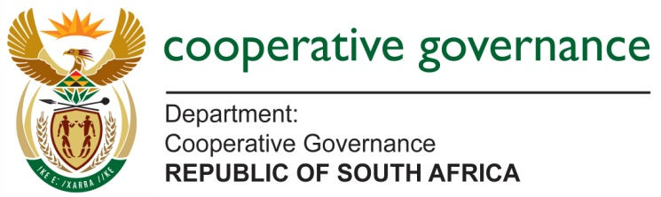

THE MINISTER

Reference No.: 2019/50

SUBJECT: PARLIAMENTARY QUESTION NO. 2019/50

Date: 10 April 2019

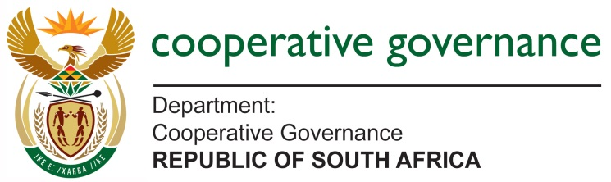
______________________________________________________________________________________

ROUTE FORM
DOCUMENT CLASSIFICATION
Confidential | x | Secret |  | Top Secret

SUBJECT | Response to PQ2019/50
DRAFTER | Ms Helle Pretorius
BRANCH | Local Government Support and Interventions Management
CHIEF DIRECTORATE | Local Government Improvement Programme
FILE REFERENCE NO | PQ2019/50 | CELL | 012 334 0734

ROUTE | SIGNATURE | DATE
Ms H Pretorius
Senior Manager: Local Government Improvement Programme
Mr T Fosi
Deputy Director-General: Local Government Support and interventions Management
MR DMG Mashitisho

Director-General: DCoG
Received by:

Deputy Ministry of Cooperative Governance
Received by:

Ministry of Cooperative Governance and Traditional Affairs

INSTRUCTIONS / NOTES

