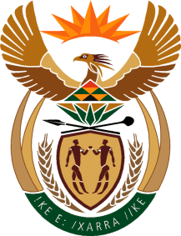

MINISTRY OF TOURISM
REPUBLIC OF SOUTH AFRICA

Private Bag X424, Pretoria, 0001, South Africa. Tel. (+27 12) 444 6780, Fax (+27 12) 444 7027
Private Bag X9154, Cape Town, 8000, South Africa. Tel. (+27 21) 469 5800, Fax: (+27 21) 465 3216

NATIONAL ASSEMBLY:

QUESTION FOR WRITTEN REPLY:
Question Number: 499
Date of Publication: 24 February 2023
NA IQP Number: 4
Date of reply:

Mr K P Sithole (IFP) to ask the Minister of Tourism:
Whether, with reference to Mr Nick Frischke, a 22-year-old German tourist who is currently missing after having been seen for the last time in the V&A Waterfront, Cape Town, on February 14, she will furnish Mr K P Sithole with the details on (a) the protocol for crimes of this nature and (b) steps her department has taken to assist in the situation; if not, why not; if so, what are the relevant details? NW544E

REPLY:

- The protocol is within the competency of the South African Police Services as the custodian of safety and security.

- The Department was informed that a case of a missing person has been opened at Pinelands Police Stations and a search was initiated by the South African Police Services.
The Western Cape Provincial Department of Economic Development and Tourism is in contact with the parents of the missing person and is providing aftercare support.
The department has also informed the German Embassy, Consul and the Department of International Relations and Cooperation.

