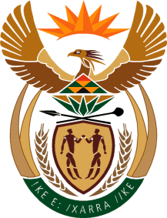

MINISTER OF TOURISM
REPUBLIC OF SOUTH AFRICA

Private Bag X424, Pretoria, 0001, South Africa. Tel. (+27 12) 444 6780, Fax (+27 12) 444 7027
Private Bag X9154, Cape Town, 8000, South Africa. Tel. (+27 21) 469 5800, Fax: (+27 21) 465 3216

NATIONAL ASSEMBLY:

QUESTION FOR WRITTEN REPLY:
Question Number: 499
Date of Publication: 23 August 2019
NA IQP Number: 10
Date of reply: 11 September 2019

Mr G R Krumbock (DA) to ask the Minister of Tourism:
(a) What tourism categories exist in the Republic, (b) how was each category formulated and (c) what targets have been set for each category? NW1492E

Reply
(a)What Tourism categories exist in the Republic
South African Tourism aligns its tourism concepts and definitions to the UN standards and guidelines. As such, the broad categories of inbound tourism, domestic tourism and outbound tourism exists.

(b)How was each category formulated
South African Tourism adopts and follows the UN standards and definitions for tourism statistical concepts. This is a link to the International Recommendations on Tourism Statistics. https://unstats.un.org/unsd/publication/Seriesm/SeriesM_83rev1e.pdf

(c) What targets have been set for each category?
South African Tourism has set targets for inbound (international) tourism and domestic holiday tourism. The targets set for the financial year 2019/20 are as follows:
- International tourism: 11,4 million (inbound tourism)
- Domestic holiday tourism: 2,7 million (domestic)

