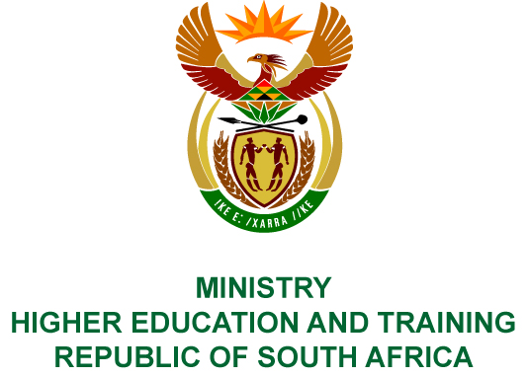
Private Bag X893, Pretoria, 0001, Tel (012) 312 5555, Fax (012) 323 5618
Private Bag X9192, Cape Town, 8000, Tel (021) 469 5150, Fax: (021) 465 7956
Memorandum from the Parliamentary Office
NATIONAL ASSEMBLY
FOR WRITTEN REPLY
QUESTION 497
DATE OF PUBLICATION OF INTERNAL QUESTION PAPER: 02/03/2018
(INTERNAL QUESTION PAPER NO 5 OF 2018)
Ms H Bucwa (DA) to ask the Minister of Higher Education and Training:
(1) Whether the technical, vocational education and training (TVET) colleges might only offer programmes on level 5 and 6 in the longer term;
(2) what is the Government’s policy position on the role of TVET colleges within the education and training spectrum in the longer term;
(2) whether the role of TVET colleges is to change in the future; if not, what is the position in this regard; if so, what are the envisaged timelines?
NW564E
REPLY:
- Technical and Vocational Education and Training (TVET) colleges will continue to offer programmes as long as they are responsive to labour market demands. For articulation purposes, colleges will offer programmes at level 5 and 6 in the main occupational and vocational programmes, and some mid-level occupational programmes. Currently some colleges are offering Higher Certificates at level 5 in partnership with Universities and Universities of Technology, which allows students to articulate from level 4 to level 5 programmes.
- Government expects that TVET colleges will become the cornerstone of the country’s skills development system as captured in the White Paper for Post-School Education and Training. TVET colleges are central to the provision of skills within the post-school education and training system. The main purpose of TVET colleges is to train young school leavers, with the required skills, knowledge and attitudes for employment or self-employment within the labour market, or to access higher learning.
- Fundamentally, the role of TVET colleges will not change. Its purpose has been, and will continue to be the supplier of mid-level skilled workers to the labour market. What needs to change is the responsiveness of colleges to such demands. In this regard, the Department is working towards transforming programme offerings in colleges, so that they become more responsive to the labour market. In some instances, the current curricula will have to be updated to make them more relevant. The latter process is ongoing in priority programme areas. Several occupational qualifications have also been developed which allows colleges to offer them on demand. The complete revision of college programmes and curricula is a medium to long-term process.

