NATIONAL ASSEMBLY
36/1/4/1(2021)

FOR WRITTEN REPLY QUESTION 496
DATE OF PUBLICATION IN INTERNAL QUESTION PAPER: 26 FEBRUARY 2021
(INTERNAL QUESTION PAPER NO 4-2021)

496. Ms N W A Mazzone (DA) to ask the Minister of Police:

- Whether he gave assurances to the fomer President, Mr J G Zuma, that he would be the person carrying out an arrest if the courts decide to issue a warrant of arrest, as a certain person (name furnished) stated on Twitter on 18 February 2021; if not, what is the position in this regard; if so, what are the relevant details;

- whether he has found that his visit to the fomer President, who faces imminent arrest for refusing to appear before the Judicial Commission of Inquiry into allegations of State Capture, Corruption and Fraud in the Public Sector including Organs of State in contravention with a Constitutional Court order, on 18 February 2021 conflicted in any way with his position as the Minister responsible for the Police Service, who would be responsible for enforcing the law and carrying out the arrest; if not, what is the position in this regard; if so, what are the relevant details?
NW552E
REPLY:

- Ministers don't effect arrest, if warrant of arrest is issued, it will follow the normal cause of procedures.

- No. As explained above, ministers don’t carry out any arrests.

Reply to questi approved/n

GENE ELE, MP
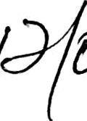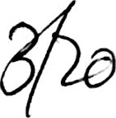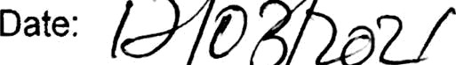MINISTER OF POLICE

