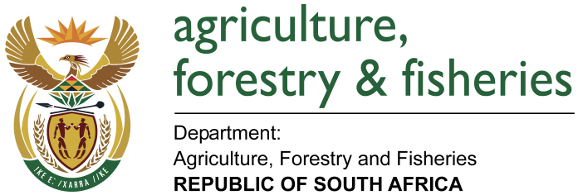
NATIONAL ASSEMBLY

WRITTEN REPLY

QUESTION 49/ NW54E

MINISTER OF AGRICULTURE, FORESTRY AND FISHERIES:
Ms L Mathys (EFF) to ask the Minister of Agriculture, Forestry and Fisheries:

QUESTION:
What (a) are the names of farmers who are subsidised by the State, (b) is the location of each farm that is subsidised, (c) does each farm produce and (d) is the monetary value of each subsidy? NW54E

REPLY:

The Department of Agriculture Forestry and Fisheries does not own land but administers it on behalf of the Department of Public Works. The land is leased to prospective producers as per prescripts defined and agreed to. The implementation of assistance to prospective producers is based on a grant system and thus does not conform to the definition of subsidising production or initiation of production enterprises.
It should be noted that in terms of the World Trade Organisation, South Africa is categorised as a developing country and provision of grants to support production is allowed.

NB: attached is the list of farms that are currently managed by the Department of Agriculture Forestry and Fisheries ANNEXURE 1

