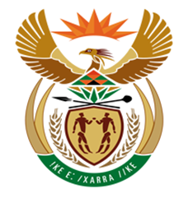

NATIONAL ASSEMBLY
QUESTION FOR WRITTEN REPLY
QUESTION NUMBER: 485 [NW542E]
DATE OF PUBLICATION: 10 MARCH 2017

485. Mr R A Lees (DA) to ask the Minister of Finance:
(1) Whether the (a) SA Airways (SAA) or (b) National Treasury has ever paid for a certain person (details furnished) to stay at the Oyster Box Hotel in Durban, KwaZulu-Natal; if not, what is the position in this regard; if so, (i) on what date(s), (ii) what is the detailed breakdown of the total costs and (iii) was the specified person accommodated in the Presidential Suite in each case;
(2) whether (a) SAA or (b) National Treasury sponsored any person to attend the event of a certain political party (details furnished) that took place at the specified hotel on 25 February 2017; if not, what is the position in this regard; if so, what are the details of the (i) person(s) sponsored and (ii) breakdown of the amounts sponsored;
(3) whether he will make a statement on these matters? NW542E
REPLY:

(1)(b) No, the National Treasury and South African Airways have not made any payment for the Board Chairperson to stay at the Oyster Box Hotel in Durban, KwaZulu-Natal. National Treasury does not pay for accommodation for non-employees based on our internal policy.

(2)(b) Prohibited in terms of the National Treasury policy on Gifts, Donations and Sponsorships.

(3) No.

