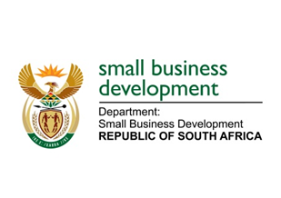
NATIONAL ASSEMBLY
QUESTION FOR WRITTEN REPLY
DUE in PARLIAMENT: FRIDAY, 10 MARCH 2023

“483. Inkosi R N Cebekhulu (IFP) to ask the Minister of Small Business Development:
With reference to the Amavulandela Funding Scheme of the Small Enterprise Finance Agency, which is designed to support persons with disabilities and offers entrepreneurs with disabilities standard credit facilities with fixed interest rates, what is the total number of persons with disabilities who have benefitted from specified funding scheme?” NW528E

REPLY: I have been advised by the department as follows:

Since the Small Enterprise Finance Agency (sefa) established the Amavulandlela Funding Scheme in December 2016 to date, the scheme has approved loans to the value of R75.3 million, disbursed R54.8 million to 39 enterprises owned by entrepreneurs with disabilities. These enterprises in turn helped create and sustain 753 jobs.

STELLA NDABENI-ABRAHAMS
MINISTER: SMALL BUSINESS DEVELOPMENT

