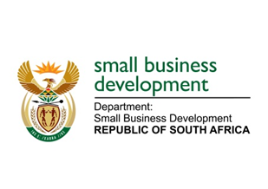
NATIONAL ASSEMBLY
QUESTION FOR WRITTEN REPLY
DUE IN PARLIAMENT: FRIDAY, 10 MARCH 2023

“482. Inkosi R N Cebekhulu (IFP) to ask the Minister of Small Business Development:
With reference to the Inyamazane Funding Scheme of the Small Enterprise Finance Agency that offers military veterans an opportunity to enter the mainstream economy by accessing credit facilities ranging from R50 000 to a maximum of R15 million to build qualifying entrepreneurial enterprises, (a) what total number of (a) small businesses have been started through the specified funding scheme and (b) military veterans have benefited?” NW527E

REPLY: I have been advised by the department as follows:

Inyamazane Funding Scheme was launched on 5 September 2018. This scheme is administered by the Small Enterprise Finance Agency (sefa).

- Since the inception of the scheme 8 (eight) enterprises were approved to the value of R25 055 376.
- R12 418 253 was disbursed to 2 (two) enterprises. sefa was not able to disburse to 6 (six) enterprises as these (enterprises) were not able to secure contracts – and these contracts were the basis for the financial support.

Enterprises that were supported are based in the Eastern Cape and Mpumalanga. The slow uptake of the scheme can be attributed to the challenges of market access which is faced by most military veterans.

sefa continues to participate in various platforms where the subject of promoting economic transformation to military veterans are explored.

STELLA NDABENI-ABRAHAMS
MINISTER: DEPARTMENT OF SMALL BUSINESS DEVELOPMENT

