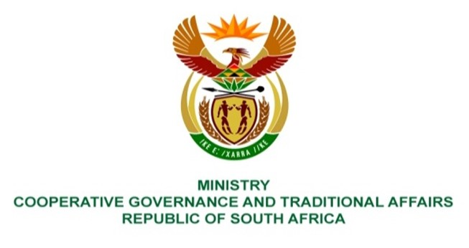

NATIONAL ASSEMBLY
QUESTIONS FOR WRITTEN REPLY

QUESTION NUMBER 481
DATE OF PUBLICATION: 25 FEBRUARY 2022

QUESTION:

481. Mr C Brink (DA) to ask the Minister of Cooperative Governance and Traditional Affairs:
Whether she has been informed of the prolonged and repeated water outages and restrictions suffered by residents of the Matjhabeng Local Municipality in the Free State in the past year due to faults in the water reticulation network and the inability of the municipality to pay its bulk water account; if not, what is the position in this regard; if so, what (a) steps is the national Government taking in terms of section 154(1) of the Constitution of the Republic, 1996, to support and strengthen the capacity of the specified municipality to provide water to the community and (b) progress has been achieved in this regard to date?
REPLY:
The MISA technical support was made aware of the water provision challenges. MISA is continually supporting MLM in infrastructure delivery and service delivery including improving access to water together with the Department of Water & Sanitation and other stakeholders through the DDM.

- National Government has deployed technical support, through MISA as mentioned in the background above, to low and medium capacity municipalities including MLM.

As part of the support package to MLM, MISA conducted a water infrastructure assessment from the 21st of August 2018 to the 31st of March 2019 that covered the nine (9) water services treatment plants in MLM. The Assessment Report was shared with the MLM and MLM is continuously supported to implement the recommendations of the report in order to improve delivery. MISA supports MLM with the implementation of projects throughout the project life cycle. Some of the specific activities of support are as follows:

    - Review of projects business plans and technical reports for registration processes,
    - General project management and project implementation planning
    - Verification of work done on infrastructure projects
    - Invoice verification on the MIG funded projects prior payment to ensure value for money is created on the ground.

MISA is also supporting MLM with the development the Social Labour Plans (SLP) in mining towns.

- National government has developed programmes to support municipalities including the MLM to perform their functions.

MLM is also supported by national government through conditional grants like the MIG and WSIG to provide access to water. MISA is providing technical support to implement these grants.

Furthermore, the Minister of Water and Sanitation has commenced a stakeholder consultation process to address the challenges that SWB is facing. To that end the Minister of Water and Sanitation wrote to the Minister of COGTA in that regard on the 4th of February 2022.

