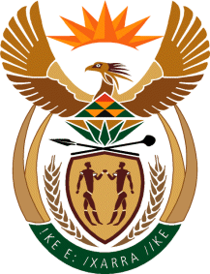

MINISTER IN THE PRESIDENCY: REPUBLIC OF SOUTH AFRICA
Private Bag X1000, Pretoria, 0001, Union Buildings, Government Avenue, PRETORIA
Tel: (012) 300 5200, Website: www.thepresidency.gov.za

NATIONAL ASSEMBLY
QUESTION FOR WRITTEN REPLY
QUESTION NUMBER: 477 – Ms TM Mbabama: DA
DATE OF PUBLICATIONS:

What (a) is the salary of each (i) Chief Executive Officer and (ii) top executive position in each state-owned entity reporting to his Office?

Reply:
(i) The total cost to company package of the CEO of the Media Development and Diversity Agency (MDDA) is R1 999 525, 44.
(ii) The Total cost to company for the Chief Financial Officer is R1 800 000.

The total cost to company package of the Executive Projects is R1 831 060, 44.

(b) Total amount each paid to attend a meeting.
Reply:
No executive gets paid to attend meetings other than for incidental expenses.

Drafter of the Reply

Name: Prof. Hlengani Mathebula
Designation: Chairperson of the Board of Directors

Recommended by:

Acting Director-General: Government Communication and Information System (GCIS)
Mr Michael Currin

Approved / Not approved

______________________
Minister in The Presidency
Ms Khumbuzo Ntshavheni, MP

