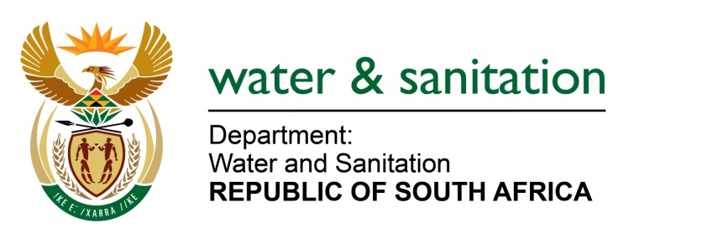

NATIONAL ASSEMBLY

FOR WRITTEN REPLY

QUESTION NO 477

DATE OF PUBLICATION IN INTERNAL QUESTION PAPER: 26 FEBRUARY 2016
(INTERNAL QUESTION PAPER NO. 4)

477. Mr D Bergman (DA) to ask the Minister of Water and Sanitation:
(1) (a) When will the second phase of the Lesotho Highlands Water Project be completed, (b) at what cost, (c) how will the second phase be funded and (d) who has been appointed as (i) the construction company and (ii) consultant engineers;
(2) what was the original (a) cost and (b) completion date of the second phase of the specified project;
(3) whether a certain person (name furnished) is still South Africa’s Chief Delegate in terms of the specified project in the Kingdom of Lesotho; if not, (a) why not, (b) who replaced her in this position and (c) who appointed the new delegate? NW531E
---00O00---
REPLY:
(1)(a) The expected delivery date of water to Gauteng is December 2024.
(1)(b) The cost at completion is expected to be R22.9 billion. This includes contingencies, escalations and exchange rate fluctuations.
(1)(c) The second phase will be funded through raising bonds in the market for which Trans Caledon Tunnel Authority (TCTA), as the funding agency, has National Treasury approval.
(1)(d)(i) Construction contractors have not been appointed yet.
(1)(d)(ii) Consulting engineers have not been appointed yet.
(2)(a) The original cost based on a feasibility study dated 2007 was R6.6 billion. The amount did not include contingencies, escalations and exchange rate fluctuations.
(2)(b) The original completion date for Lesotho Highland Water Project (LHWP) Phase II was 2019.
(3) No, Dr Zodwa Dlamini is not the Republic of South Africa’s (RSA) Chief Delegate for the Lesotho Highland Water Commission (LHWC).
(3)(a) Dr Dlamini was replaced in December 2015.
(3)(b) The Republic of South Africa’s Chief Delegate is Mr. Bhekizwe Nkosi who was appointed in December 2015.
(3)(c) I have appointed the new delegate.
---00O00---

