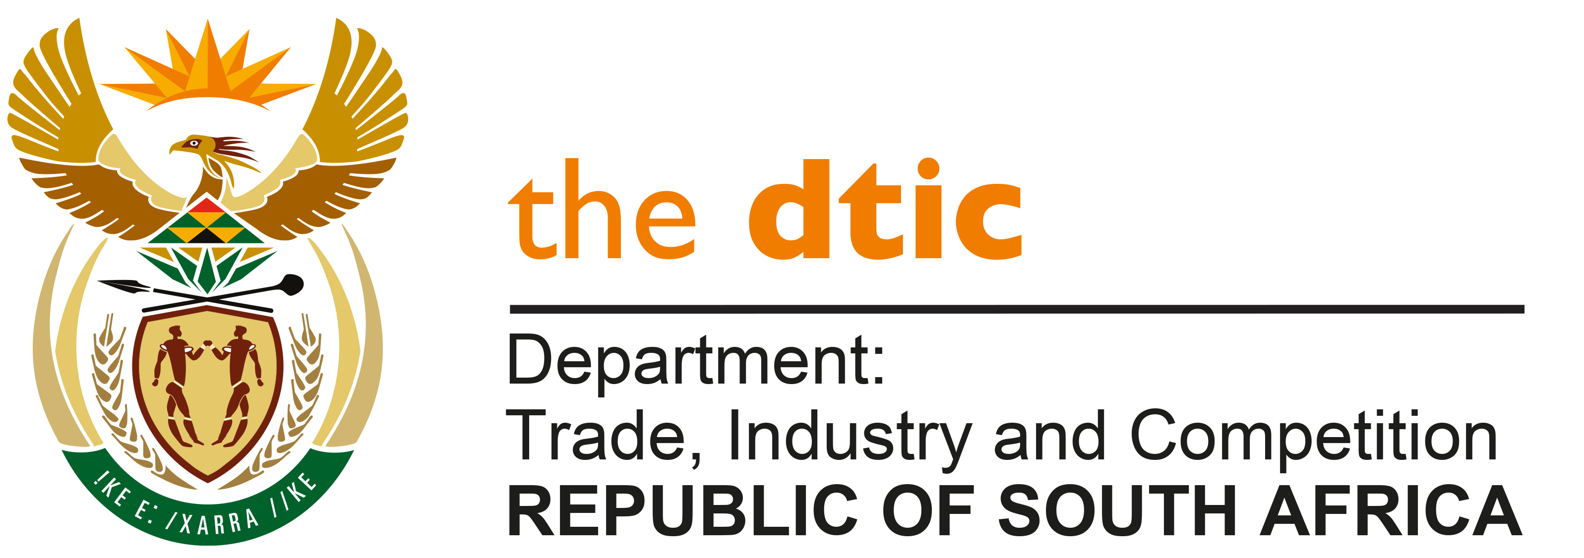

THE NATIONAL ASSEMBLY

QUESTION FOR WRITTEN REPLY

Parliamentary Question 475

Dated Published: 26 February 2021

Mr M J Cuthbert (DA) to ask the Minister of Trade, Industry and Competition:
(1) Whether, with reference to the African Continental Free Trade Area (AfCFTA), and the requirement that member states should complete their tariff reduction schedules and finalise essential rules of origin by July 2021, (a) the Republic has submitted the tariff reduction schedule and (b) will she furnish Mr MJ Cuthbert with a copy of the tariff reduction and rules; if not, why not; if so, on what date;
(2) whether the Republic has submitted its position on rules of origin to the (AfCFTA) Secretariat; if not, what is the position in this regard; if so, what are the relevant details;
(3) whether the Republic has pledged any funds to the AfCFTA Secretariat; if not, what is the position in this regard; if so, (a) what amount has been pledged and (b) for what purpose? NW531E

REPLY

- (a) SA, together with Members of the Southern African Customs Union (SACU), has submitted a tariff offer to AU Members. The SACU offer is conditional on receiving a reciprocal offer from AU trading partners as required by the AU Summit Decision of 5 December 2020. A copy of the offer may be accessed at http://www.thedtic.gov.za/wp-content/uploads/LSec-CE-TA-2020-072December2020.pdf

- South Africa, together with Members of SACU, has negotiated and reached agreement on applicable rules of origin with AU Members for 81.5% of all products specified under the World Customs Organisation Harmonised System (HS) classification at a six digit level.

3) SA contributes to the budget of the AfCFTA Secretariat through its normal contributions to the African Union Commission.

-END-

