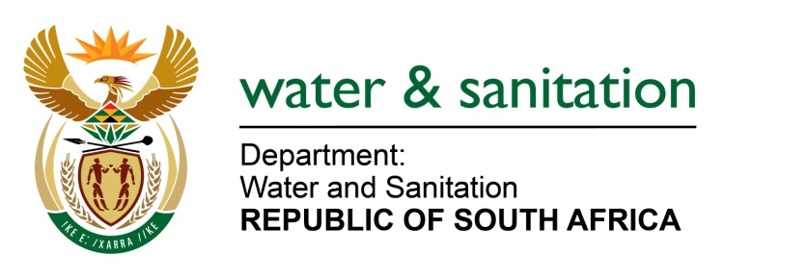

NATIONAL ASSEMBLY

FOR WRITTEN REPLY

QUESTION NO 475

DATE OF PUBLICATION IN INTERNAL QUESTION PAPER: 26 FEBRUARY 2016
(INTERNAL QUESTION PAPER NO. 4)

475. Mr. L J Basson (DA) to ask the Minister of Water and Sanitation:
(1) (a) What is the (i) budget and (ii) cost to date of the construction of the 20 megaliter per day water purification plant in the Madibeng Local Municipality in North West, (b) when will the specified plant be completed and (c) at what estimated cost;
(2) whether the cost of building the specified plant has increased against the original budget since construction started; if so, what are the (a) amount and (b) reasons in each case;
(3) whether the specified municipality is contributing financially to the construction of the specified plant; if not, why not; if so, what (a) amount and (b) are the further relevant details;
(4) whether the specified municipality has sufficient funds available to assist in funding the construction of the specified plant; if not, (a) why not and (b) how will the construction of the specified plant be completed; if so, what are the relevant details? NW529E
---00O00---
REPLY:

(1)(a)(i) The budget allocation for the upgrade of Brits Water Treatment Works (WTW) is R60 million.

(1)(a)(ii) The expenditure to date is R36 million.

(1)(b) The first module is envisaged to be completed by July 2016 and overall project completion is August 2018.

(1)(c) The estimated cost for the first module is R 93 million and overall project estimate cost is R800 million.

(2) No, the cost has not increased.

(2) (a) Falls away.

(2) (b) Falls away

(3) The Madibeng Local Municipality is not providing financial support due to financial constraint.

(3)(a Falls away.

(3)(b) Falls away.

(4)(a) The funding is enough to carryover the construction, for the completion of module 1 upgrade.

(4)(b) The construction will be done in phases until completion.

---00O00---

