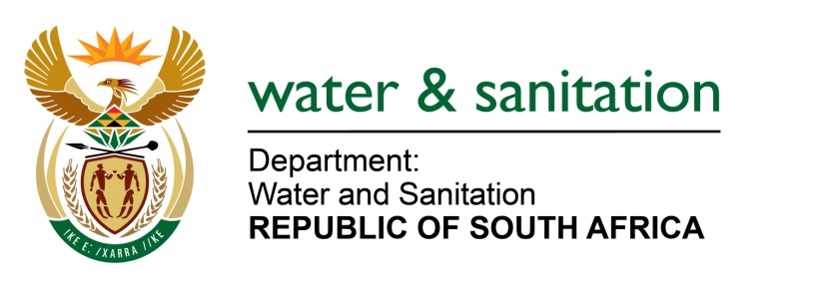

NATIONAL ASSEMBLY

FOR WRITTEN REPLY

QUESTION NO 474

DATE OF PUBLICATION IN INTERNAL QUESTION PAPER: 26 FEBRUARY 2016
(INTERNAL QUESTION PAPER NO. 4)

474. Mr L J Basson (DA) to ask the Minister of Water and Sanitation:
(1) Whether any investigations, both formal and informal, have been undertaken in Joubertina in the Kou-Kamma Local Municipality in the Eastern Cape to determine the extent of the lack of water in the town; if not, why not; if so, (a) what were the outcomes of these investigations in terms of infrastructure that needs to be (i) repaired and (ii) upgraded and (b) how (i) long will it take and (ii) will it be funded in each case;
(2) whether her department is providing any assistance to the specified municipality to deliver water to the community in Joubertina, where there is reportedly no more water in the taps; if not, why not; if so, what are the relevant details? NW528E
---00O00---

REPLY:

- Yes, investigations were conducted most recently on 04 February 2016 to determine the extent of lack of water in Jourbertina, Koukamma Eastern Cape.

(1)(a) It was discovered that the dam level is critically low at 0,5m, the storage enough to last for a day or two.

(1)(a)(i) The gravity pipeline from Joubertina to the Water Treatment Plant is exposed due to flooding.

(1)(a)(ii) The pipeline has to be relocated and other sections have several leaks and have to be repaired/ upgraded.

(1)(b) Funding was made available by my Department to relocate the exposed pipeline including plugging the leaks, Amatola Water has been appointed and is already onsite.

(1)(b)(i) This part of the project should be completed by end March 2016.

(1)(b)(ii) Further repairs to the system will be funded through Accelerated Community Infrastructure Programme (ACIP).

My Department has been involved in Koukamma Local Municipality (LM) since 2014/15 where a community water supply project was implemented to do research on existing water use within the Koukamma area, research on surface water resources within the Koukamma area, investigate raw water storage at Krakeel and investigate the condition of the Kareedouw Water Treatment Works (WTW) and on the groundwater resources within the Krakeel and Kareedouw area.

Based on the outcomes of the research done, the Water Treatment Works (WTW's) of Kareedouw was refurbished since it was basically non-functional. Several boreholes were drilled and equipped, chemical analysis of the water was done and electricity had to be provided where boreholes were drilled. Meters were also installed.

Water Conservation Demand Management (WCDM) Project was also implemented to develop a WCDM strategy. Water Safety Plans were prepared for each of the 11 water supply systems, retrofit Programme (Toilet Retrofit Project) was implemented, awareness and education program was implemented at schools, a water meter and leak audit was done for each and every town in Koukamma LM as well as water balances, marketing and publicity was done through posters, entrance town billboards, pamphlets and information.

- Yes, my Department is providing assistance to the municipality in the following.

- A 18 000L tanker was sent to Joubertina and has been operational during
February 2016.
- 200 X 25L of clean water was also sent to Jourbertina on
1 February 2016
- Amatola Water has been appointed to replace and relocate a section of the exposed bulk pipeline to the town. Leaks will also be detected and repaired. The project is currently under construction.

---00O00---

