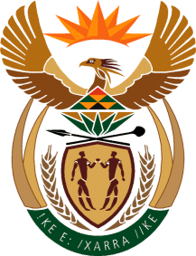

MINISTRY OF TOURISM
REPUBLIC OF SOUTH AFRICA

Private Bag X424, Pretoria, 0001, South Africa. Tel. (+27 12) 444 6780, Fax (+27 12) 444 7027
Private Bag X9154, Cape Town, 8000, South Africa. Tel. (+27 21) 469 5800, Fax: (+27 21) 465 3216

NATIONAL ASSEMBLY:

QUESTION FOR WRITTEN REPLY:
Question Number: 472
Date of Publication: 26 February 2021
NA IQP Number: 4
Date of reply: 04 March 2021

Mr M S F de Freitas (DA) to ask the Minister of Tourism:
(a) What is being done to reduce outsourced functions and services within the national Department of Tourism, (b) what are the (i) time frames, (ii) timelines and (iii) deadlines in this regard, (c) what functions and services will be prioritised and (d) how will this be (i) monitored and (ii) measured? NW528E

REPLY:
- What is being done to reduce outsourced functions and services within the department.
At this stage the department has no plan to reduce outsourced functions and services within the department, due to the nature of these services and limited compensation budget. However, the department enters into negotiations with winning bidders for different services to ensure efficiency in the use of limited fiscal resources.

- (i)-(iii) Not applicable

- Not applicable

- (i) – (ii) Not applicable.

