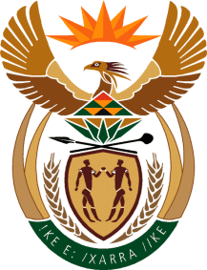

MINISTRY OF TOURISM
REPUBLIC OF SOUTH AFRICA

Private Bag X424, Pretoria, 0001, South Africa. Tel. (+27 12) 444 6780, Fax (+27 12) 444 7027
Private Bag X9154, Cape Town, 8000, South Africa. Tel. (+27 21) 469 5800, Fax: (+27 21) 465 3216

NATIONAL ASSEMBLY:

QUESTION FOR WRITTEN REPLY:
Question Number: 472
Date of Publication: 10 March 2017
NA IQP Number: 9
Date of reply: 17 March 2017

Mr W Horn (DA) to ask the Minister of Tourism:
Whether his department procured any services from and/or made any payments to (a) Mr MzwaneleManyi, (b) the Progressive Professionals Forum, (c) the Decolonisation Fund and/or (d) the Black Business Council; if not, in each case, why not; if so, what (i) services were procured, (ii) was the total cost, (iii) is the detailed breakdown of such costs, (iv) was the total amount paid, (v) was the purpose of the payments and (vi) is the detailed breakdown of such payments in each case? NW528E
Reply:
- Mr MzwaneleManyi
(i) No services procured
(ii)- (vi) Not applicable
- Progressive Professionals Forum
(i) No services procured
(ii)- (vi) Not applicable
- Decolonisation Fund
(i) No services procured
(ii)- (vi) Not applicable
- Black Business Council
(i) No services procured
(ii)- (vi) Not applicable

