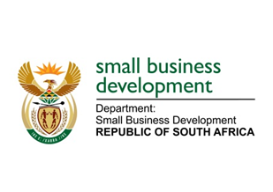
NATIONAL ASSEMBLY
QUESTION FOR WRITTEN REPLY
DUE IN PARLIAMENT: FRIDAY, 10 MARCH 2023

“471. Mr G R Krumbock (DA) to ask the Minister of Small Business Development:
What (a) is the salary of each (i) chief executive officer and (ii) top executive position in each state-owned entity reporting to her and (b) total amount does each get paid to attend a meeting?” NW515E

REPLY: I have been advised by the department as follows:

The Small Enterprise Development Agency (Seda):
- Annual package of Top management in Seda:
Title(i) & (ii) | Annual package in Rands
Acting Chief Executive Officer | R 2 682 646
Executive Manager: Enterprise Development | R 1 846 069
Executive Manager: Seda Technology Programme | R 1 800 000
Chief Strategy Information Officer | R 1 737 200
Acting Chief Financial Officer | R 1 737 200
Acting Executive Manager: Corporate Services | R 1 737 200
TOTAL | R 11 540 315

- No payments for meetings attended.

The Small Enterprise Finance Agency (sefa):
- The salaries of all executives are disclosed in the sefa annual report each year, including the Chief Executive Officer. Please refer to the attached extract from the financial statements, Annexure A (note 10.2.2) in the financial statement section of the annual report on our website.

- Executives are not remunerated for attending meetings as they are Executive Officials and not Non-Executive Directors.

STELLA NDABENI ABRAHAMS
MINISTER: DEPARTMENT OF SMALL BUSINESS DEVELOPMENT

