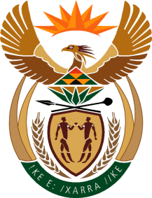

MINISTRY OF TOURISM
REPUBLIC OF SOUTH AFRICA

Private Bag X424, Pretoria, 0001, South Africa. Tel. (+27 12) 444 6780, Fax (+27 12) 444 7027
Private Bag X9154, Cape Town, 8000, South Africa. Tel. (+27 21) 469 5800, Fax: (+27 21) 465 3216

NATIONAL ASSEMBLY:

QUESTION FOR WRITTEN REPLY:
Question Number: 471
Date of Publication: 26 February 2021
NA IQP Number: 4
Date of reply: 08 March 2021

Mr M S F de Freitas (DA) to ask the Minister of Tourism:
(a) What is being done to develop internal capacity within SA Tourism (b) what are the (i) time frames, (ii) timelines and (iii) deadlines in this regard and (c) on what areas will such capacity development focus? NW527E

REPLY:

- A Workplace Skills Plan (WSP) is developed and submitted to CATHSSETA on an annual basis. The Workplace Skills Plan is informed by needs analysis from the Annual Performance Plan, Business Units Plans as well as individual employees Personal Development Plans.

- (i)- (iii)The Workplace Skills Plan is developed and submitted to CATHSSETA by end of April annually for approval. Subsequent to that the identified training interventions are implemented throughout the financial year. An Annual Training Report (ATR) is further compiled to report progress on the implemented training interventions and the ATR is submitted with a WSP of the following year.

- Training interventions that are identified mainly focus on building core and functional capabilities across South African Tourism value chain. The following are some of the prioritised capacity development focus areas:
,
• Sales and Marketing,
• Project Management,
• Business Communications,
• People Management, and
• Business Risk Management.

