environmental aFairs
Department: Environmental Affairs
REPUBLIC OF SOUTH AFRICA

NATIONAL ASSEMBLY
(For written reply)
QUESTION NO. 47 {NW1004E}
INTERNAL QUESTION PAPER NO. 1 of 2019

DATE OF PUBLICATION: 20 June 2019

Mr N Paulsen (EFF) to ask the Minister of Environmental Affairs:
Who are the current 20 largest recipients of fishing quotas in terms of (a) total fishing quota and (b) type of fish?

47. THE MINISTER OF ENVIRONMENTAL AFFAIRS REPLIES:

- TABLE 1. The 20 largest recipents of fishing quotas (in tonnages) of Total Allowable Catch/Quantum (TAC) controlled fisheries.
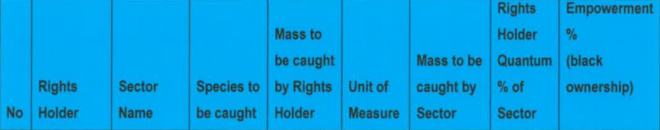
1. | Premier Fishing SA (Pty) Ltd | South  Coast Rock Lobster | South  Coast Rock Lobster | 128779 | kilograms | 321000 | 40.12 | 78.24
2. | Sea Harvest Corporation | Hake Deep Sea Trawl | Hake | 46205.905 | tons | 122430.737 | 37.74 | 83.83

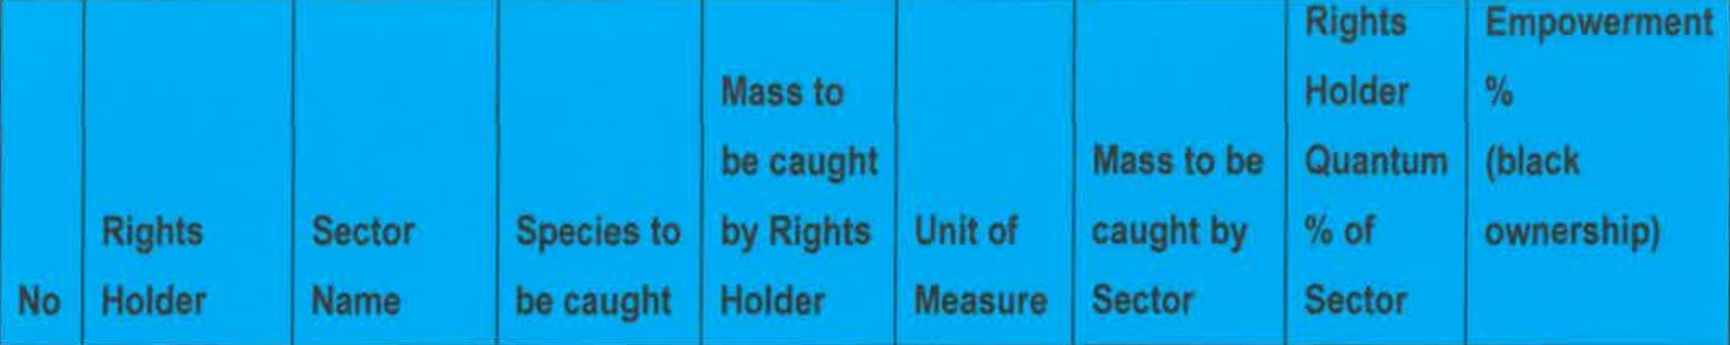
 | (Pty) Ltd
3. | lrvin and  Johnson Ltd | Hake Deep Sea Trawl | Hake | 37956.04 | tons | 122430.737 | 31.00 | 41.1
4. | Ziybuya  Fishing (Eastern Cape) (Pty) Ltd | Patagonian Toothfish | Patagonian Toothfish | 162.9 | tons | 543 | 30.00 | 100
5. | Ruwekus Fishing (Pty) Ltd | South  Coast Rock Lobster | South  Coast Rock Lobster | 77332 | kilograms | 321000 | 24.09 | 67.92
6. | Seavuna  Fishing (Pty) Ltd | Hake  Inshore Trawl | Sole | 143.953 | tons | 627 | 22.96 | 84.86
7. | Lucky Star Limited | Small Pelagics | Sardine  by-catch - Anchovy | 561.69 | tons | 3250 | 17.28 | 37.25
8. | Lucky Star  Limited | Small  Pelagics | Anchovy | 60114.94 | tons | 347860 | 17.28 | 37.25
9. | Oceana Lobster Limited | West  Coast Rock Lobster (Offshore) | West Coast Rock Lobster | 85683.1 | kilograms | 563910 | 15.19 | 78.26
10. | Lucky Star  Limited | Small  Pelagics | Sardine  by-catch | 37.57 | tons | 250 | 15.03 | 37.25

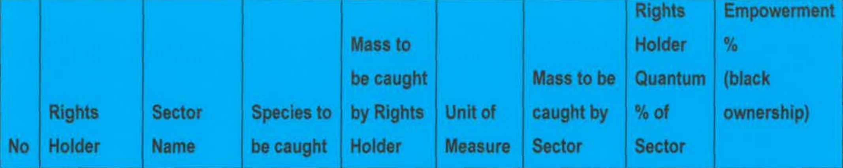
juvenile)
with directed Sardine
11. | Lucky Star  Limited | Small  Pelagics | Sardine | 731.79 | tons | 4750 | 15.03 | 37.25
12. | Irvin &  Johnson Ltd | Hake  Inshore Trawl | Hake | 1297.516 | tons | 9013.802 | 14.39 | 41.1
13. | Viking  Inshore Fishing (Pty) Ltd | Hake Inshore Trawl | Sole | 85.343 | tons | 627 | 13.61 | 3&22
14. | Seavuna  Fishing Co. (Pty) Ltd | Hake  Inshore Trawl | Hake | 1225.057 | tons | 9013.802 | 13.59 | 84.86
15. | Suidor  Fishing  (Pty) Ltd | Patagonian  Toothfish | Patagonian  Toothfish | 72.76 | tons | 543 | 13.40 | 51
16. | Bato Star  Fishing  (Pty) Ltd | Patagonian Toothfish | Patagonian Toothfish | 72.76 | tons | 543 | 13.40 | 85
17. | Arniston  Fish Processors (Pty) Ltd | Patagonian  Toothfish | Patagonian  Toothfish | 72.76 | tons | 543 | 13.40 | 38
18. | Irvin &  Johnson | Patagonian  Toothfish | Patagonian  Toothfish | 72.76 | tons | 543 | 13.40 | 41.1

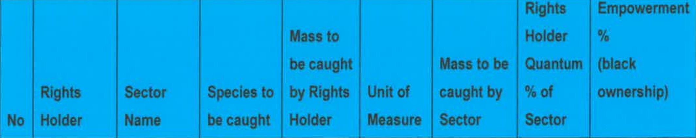
 | Ltd
19. | Amawandle Pelagic (Pty) Ltd | Small  Pelagics | Sardine | 533.01 | tons | 4750 | 11.22 | 53
20. | Amawandle Pelagic (Pty) Ltd | Small Pelagics | Sardine  by-catch juvenile) with directed Sardine | 28.05 | tons | 250 | 11.22 | 53

- TABLE 2. The 20 largest recipents of fishing allocations in Total Applied Effort (TAE) controlled fisheries
 | " | -- |  | " " | " | .
1 | Talhado Fishing  Enterprises (Pty)  Ltd | Squid | 134 | Crew | 2443 | 5.49 | Unknown
2 | Dazzalle Traders  (Pty) Ltd | Squid | 122 | Crew | 2443 | 4.99 | 67.37
3 | Southern Boat  Assistants Co (Pty) Ltd | Abalone | 2175 | Kilograms | 50500 | 4.31 | 100
4 | Calamari Fishing  (Pty) Ltd | Squid | 104 | Crew | 2443 | 4.26 | 54.81

r '  )fl, | - 'T ' '  J,* | '  g I '
S | Balobi Fishing  Enterprises (Pty) Ltd | Squid | 97 | Crew | 2443 | 3.97 | 51
6 | Visko  Seeprodukte (Pty)  Ltd | Squid | 86 | Crew | 2443 | 3.52 | 70
7 | Umsobomvu  Fishing (Pty) Ltd | Squid | 77 | Crew | 2443 | 3.15 | 53.15
8 | Premier Fishin  SA (Pty) Ltd | Squid | 74 | Crew | 2443 | 3.03 | 78.24
9 | Nozamile Fishin  (Pty) Ltd |  | 69 | Crew | 2443 | 2.82 | 51
10 | Knsyna Fishing  Company (Pty) Ltd | Squid | 68 | Crew | 2443 | 2.78 | 70
11 | Canan Fishing  (Pty) Ltd | Squid | 66 | Crew | 2443 | 2.70 | Unknown
12 | Sceptre Fishin  (Pty) Ltd g | „ d | 54 | Crew | 2443 | 2.21 | 618
13 | Lithalethu Fishing p  ty) Ltd | Squid | 47 | Crew | 2443 | 1.92 | 51
14 | Letap CC | Squid | 44 | Crew | 2443 | 1.80 | 100
15 | Striker Fishig  Enterprises (Pty) Ltd | Squid | 41 | Crew | 2443 | 1.68 | 60
16 | Latief Albertyn  Fisheries CC | Abalone | 729 | Kilograms | 50500 | 1.44 | 100
17 | Western Star  Enterprises | Squid | 33 | Crew | 2443 | 1.35 | 76
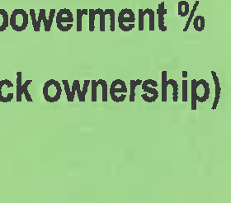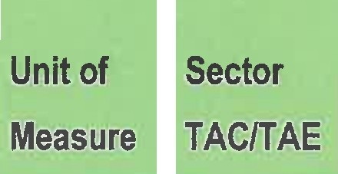

 | Fishing (Pty) Ltd
18 | Prima  Seevisserye  (Edms) Ltd | Squid | 32 | Crew | 2443 | 1.31 | Unknown
19 | Moneyline 1781  cc | Abalone | 588 | Kilograms | 50500 | 1.16 | 100
20 | Columbia Fishing  CC | Abalone | 582 | Kilograms | 50500 | 1.15 | 100
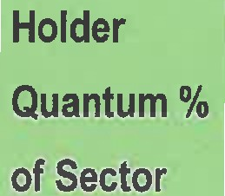

Regards

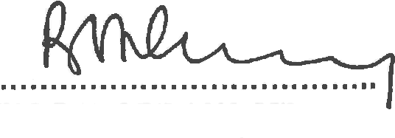
MS B D CREECY, MP
MINISTER OF ENVIRONMENT, FORESTRY AND FISHERIES

DATE :... .. ...). ..”..! ..

