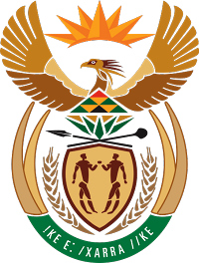

**MINISTRY FOR COOPERATIVE GOVERNANCE AND TRADITIONAL AFFAIRS**

**REPUBLIC OF SOUTH AFRICA**

**NATIONAL ASSEMBLY**

**QUESTIONS FOR WRITTEN**

**QUESTION NUMBER 2018/47**

**DATE OF PUBLICATION: 08 FEBRUARY 2018**

**Mr M Waters (DA) to ask the Minister of Cooperative Governance and Traditional Affairs:**

Whether, with reference to the reply to question 3455 on 3 December 2010, all the loans or bonds have been fully repaid; if not, (a) why has each loan or bond not been fully repaid, (b) by what date will it be repaid, (c) what amount has the Ekurhuleni Metropolitan Municipality paid in interest to date and (d)(i) on what date was the last payment made on the specified loans and (ii) what was the amount that was paid; if so, (aa) on what date was the final payment made and (bb) what is the interest amount that the specified municipality paid for the loan or bond in each case?

**Reply:**

Yes, the City of Ekurhuleni (CoE) has repaid some of the loans since December 2010.

(a & b) The following loans have been fully paid at the respective maturity dates (See table 1 below):

* 1. December 2001- R150 million from INCA @ 12.25% (Annuity Loan)
  2. March 2002- R150 million from DBSA @ 13.5% (Annuity Loan)
  3. March 2003 – R291 million from DBSA @ 12.2% (Annuity loan)

The CoE follows a scheduled interest and capital repayment regime on its long-term liabilities. The outstanding balances are due to the fact that loans and bonds have not yet reached their redemption/maturity dates. Refer to table 1 below.

**Table1: CoE liability profile**

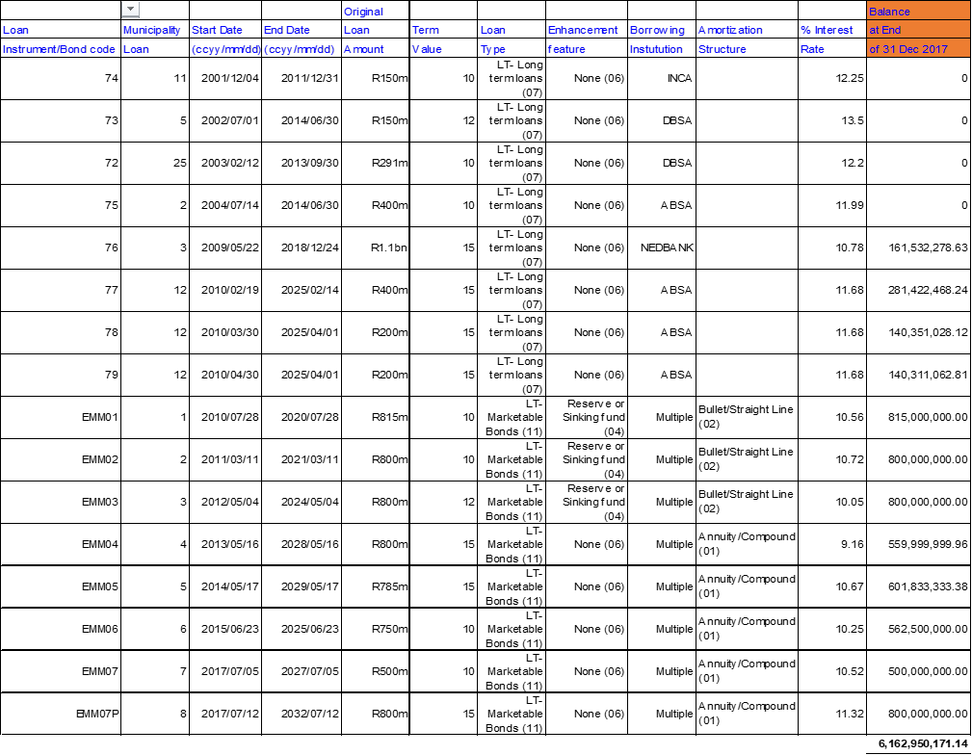

(c) Cumulative interest paid on the loans and bonds from the original date of attainment to 31 Dec 2017 is shown in table 2 below:

**Table 2**



Cumulative interest paid to date on CoE loans and bonds amounts to R3.5bn. The new bonds, EMM07 and EMM07P were taken in July 2017 and their first interest payments were due in January 2018.

(d) The last interest payment dates and amounts are shown in table 3 below:

**Table 3**



The reply to question 2018/47 is a follow-up to question 3455, which was published on 3 December 2010.