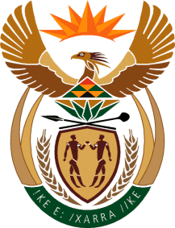

MINISTRY OF TOURISM
REPUBLIC OF SOUTH AFRICA

Private Bag X424, Pretoria, 0001, South Africa. Tel. (+27 12) 444 6780, Fax (+27 12) 444 7027
Private Bag X9154, Cape Town, 8000, South Africa. Tel. (+27 21) 469 5800, Fax: (+27 21) 465 3216

NATIONAL ASSEMBLY:

QUESTION FOR WRITTEN REPLY:
Question Number: 469
Date of Publication: 26 February 2021
NA IQP Number: 4
Date of reply: 21 April 2021

Mr H S Gumbi (DA) to ask the Minister of Tourism:
What (a) are the (i) legislative and (ii) policy responsibilities and (b) is the purpose of the Community Tourism Organisation? NW525E

REPLY:
The Department of Tourism does not have policy and/or legislative responsibilities regarding Community Tourism Organisations. However, the department has a responsibility to reach out to tourism stakeholders at all levels, and to maintain sound intergovernmental relations by working with and through provinces and local government where appropriate.

