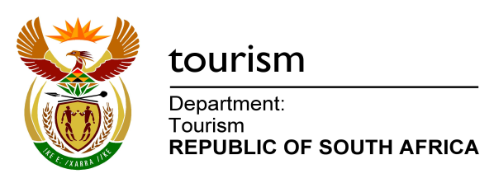

NATIONAL ASSEMBLY:

QUESTION FOR WRITTEN REPLY:
Question Number: 469
Date of Publication: 25 February 2016
NA IQP Number: 4
Date of reply:

Mr J Vos (DA) to ask the Minister of Tourism:
With reference to his comments made during his speech on 16 February 2016 in the debate on the President’s State of the Nation Address, (a) which small, medium and macro enterprises are benefitting from the support of tourism and (b) how many jobs were created in each case? NW523E

REPLY:
- In the 2015/16 financial year, the department is supporting one hundred (100) rural tourism SMMEs through the Tourism Enterprise Partnership (TEP) programme. In the second quarter 92 enterprises were supported on mentorship, business training, and marketing / market access and business development fund assistances and in the third quarter 78 enterprises were supported. The types of tourism businesses supported included accommodation establishments, restaurants, arts and crafts, tour operators and tourism attractions. The department contributed R13.5 million towards the partnership. The department has signed an MOU with the Ministry of Small Business Development to stimulate the establishment of new SMMEs, starting from the 2016/17 financial year.

- TEP reported that 1,556 Full Time Equivalent (FTEs) jobs were created in the second and third quarter of the 2015/16 financial year.

