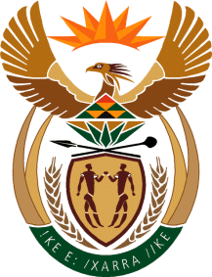

MINISTRY OF TOURISM
REPUBLIC OF SOUTH AFRICA

Private Bag X424, Pretoria, 0001, South Africa. Tel. (+27 12) 444 6780, Fax (+27 12) 444 7027
Private Bag X9154, Cape Town, 8000, South Africa. Tel. (+27 21) 469 5800, Fax: (+27 21) 465 3216

NATIONAL ASSEMBLY:

QUESTION FOR WRITTEN REPLY:
Question Number: 468
Date of Publication: 26 February 2021
NA IQP Number: 4
Date of reply: 21 April 2021

Mr H S Gumbi (DA) to ask the Minister of Tourism:
What is the (a) name, (b) surname, (c) telephone number and (d) email address of each chairperson of the Community Tourism Organisation? NW524E

REPLY:

The Department of Tourism does not keep data on Community Tourism Organisations (CTOs) and works through provinces and local government as points of entry when it comes to outreaches and engagements with local tourism stakeholders including CTOs. The Honourable member may directly liaise with relevant province/s and/or local government in this regard.

