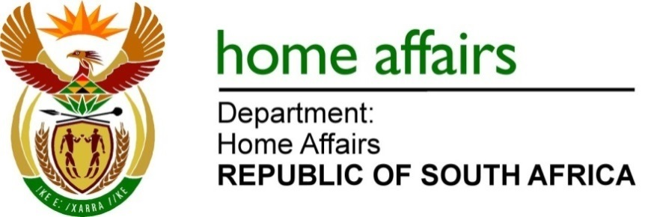
NATIONAL ASSEMBLY

QUESTION FOR WRITTEN REPLY

QUESTION NO. 4674

DATE OF PUBLICATION: FRIDAY, 2 DECEMBER 2022

INTERNAL QUESTION PAPER 51 – 2022

4674. Mrs L F Tito (EFF) to ask the Minister of Home Affairs:

Whether he has been advised of numerous cases of family members who are sent from pillar to post due to the mistakes made by his department on death certificates, such as identifying a deceased person as divorced where the person was never married before; if not, what is the position in this regard; if so, what are the relevant details? NW5797E

REPLY:

No, the Department has however issued a circular to all its local front offices directing them on the process and the email address to be used by offices to update or amend the marital status of individuals including the deceased on the National Population Register(NPR).

The relevant details should include the following:
- Affidavit from a family member confirming that the deceased person was never married.
- ID copy of the deceased person
- ID copy of the informant
- Copy of death certificate
The Department, if furnished with the details as alluded to above, will investigate and analyse the veracity of the information, and update the details on NPR accordingly.

END

