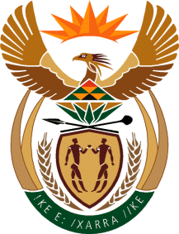

MINISTRY OF TOURISM
REPUBLIC OF SOUTH AFRICA

Private Bag X424, Pretoria, 0001, South Africa. Tel. (+27 12) 444 6780, Fax (+27 12) 444 7027
Private Bag X9154, Cape Town, 8000, South Africa. Tel. (+27 21) 469 5800, Fax: (+27 21) 465 3216

NATIONAL ASSEMBLY:

QUESTION FOR WRITTEN REPLY:
Question Number: 467
Date of Publication: 26 February 2021
NA IQP Number: 4
Date of reply: 21 April 2021

Mr H S Gumbi (DA) to ask the Minister of Tourism:
What total number of community tourism organisations are currently operational in each province? NW523E

REPLY:

The Department of Tourism does not keep data on Community Tourism Organisations. The Department’s point of entry to community organisations is through Provincial and Local government with due recognition of the concurrency of the tourism legislative mandate. The department maintains this approach as it has worked effectively in terms of outreach and engagements with local tourism communities as well as from an intergovernmental relations point of view. Thus, the department acknowledges concurrent legislative competence and that local govenment is responsible for the development of local tourism including matters related to community tourism organisations.

