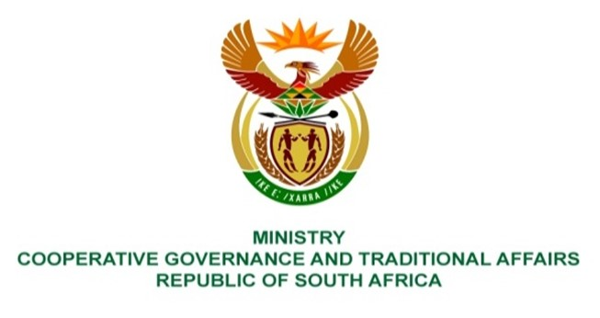

NATIONAL ASSEMBLY
QUESTIONS FOR WRITTEN REPLY

QUESTION NUMBER: 460

460. Mrs W R Alexander (DA) to ask the Minister of Cooperative Governance and Traditional Affairs:
What (a) is the salary of each (i) chief executive officer and (ii) top executive position in each state-owned entity reporting to her and (b) total amount does each get paid to attend a meeting? NW499E

REPLY:
Municipal Infrastructure Support Agent (MISA)
- Salary of:-
- Chief Executive Officer (R 2 068 458)
- Deputy Director-General: IDMS (R1 765 512)
Deputy Director-General: TSS (R1 590 747)

- None of the above members are paid to attend meetings.
Municipal Demarcation Board (MDB)

- Salary of:-
- Chief Executive Officer = R1,661,293.40.
- Chief Operations Officer = R1,518,715.20
Chief Financial Officer = R1,453,467.12
Executive Manager: Corporate Services = R1,330,516.44

- None of the above members are paid to attend meetings.
South Africa Local Government Association (SALGA)
- Salary of:-
- Chief Executive Officer – Vacant
- Chief Officer – MF FP and Economic Growth - Vacant
Chief Operating Officer – R 2 775 127.52
Chief Financial Officer – R 2 083 302.48
Chief Officer: Municipal Governance and Capabilities – R 2 255 708.40
Chief Officer: ID STS and Sustainability – R 2 166 217.56
Chief Officer: Human Capital and Corporate Services – R 2 013 400.36
Chief Digital Officer – R 1 824 597.72
- None of the above members are paid to attend a meeting.
South Africa Cities Network (SACN)
- Salary of:-
- Chief Executive Officer – R 2 902 639,34
- Executive Manager: Governance and Strategies – R 2 005 284.00
Executive Manager: Programmes and Researches – R 2 005 284.00
Executive Manager: Finance and Corporate Services – R 2 005 284,00
- None of the above members are paid to attend a meeting.
CRL Commission
- Salary of:-
- Chief Executive Officer – R 1 347 606
- Chief Financial Officer – R 1 302 102
Senior Manager 1 - R 1 226 817
Senior Manager 2 - R 1 138 800

- None of the above members are paid to attend a meeting.

End.

