’•‹•. -.‹

MINBTRY OF MINERAL RESOURCES REPUBLIC OF SOUTH AFRICA

PRIVATE BAG x 59, PRETORIA, 0001, Tel (012) 444 3979, Fax (012) 444 3145
PRIVATE BAG x 9111, CAPE TOWN, 8000 (021) 462 2310, Fax (021) 461 0859
Enquiries: Carmichael Ngalo @ Carmichael.ngalo@dmr.gov.za

Memorandum: Parliamentary Liaison Office

NATIONAL ASSEMBLY QUESTION FOR WRITTEN REPLY

QUESTION NUMBER: 460 ADVANCE NOTICE No: NW1452E

DATE OF PUBLICATION IN INTERNAL QUESTION PAPER: 23 Aug 2019 INTERNAL QUESTION PAPER NUMBER: 12
460. Mr H C C Kruger (DA) to ask the Minister of Mineral Resources and Energy:

- Whether his department received prospecting applications for mining activities in (a) Komatipoort, (b) Marloth Park, (c) Hectorspruit, (d) Malelane and/or (e) Nkomazi in each of the past three years; if so, what are the details of the (i) Geographic Information System coordinates of each site and (ii) dates of public participation meetings held for each application;

whether he will furnish Mr H C C Kruger with copies of the (a) environmental impact assessments and (b) water licence approvals for each application? NW1452E

Reply

- Please see Annexure A

- (a) Yes, the Minister will furnish the copies of the Environmental Impact Assessments upon request

(b) Water Use License Approvals fall within the competence of the Department of Water and Sanitation in terms of the National \/\later Act 36 of 1998

ANNEXURE A
MINISTRY OF MINERAL RESOURCES

REPUBLIC OF SOUTH AFRICA

REF NUMBER |  |  | Date of Public Participation (ii)
MP 30/5/1/1/2/4218 PR | 31,88271269180 | -25,73419908670 | 24/02/2009
MP 30/5/1/1/2/0912 PR | 31,82637458710 | -25,69166262520 | 17/02/2006
MP 30/5/1/1/2/0787 PR | 31,79476781810 | -25,83804059790 | refused no consultation
MP30/5/1/1/2/4524 PR | 31,83482205530 | -25,64327422090 | withdrawn
MP 30/5/1/1/2/1325 PR | 31,91839345340 | -25,75332860260 | 2006/02/10
MP 30/5/1/1/2/0720 PR | 31,82188617410 | -25,90884537650 | 2005/06/10
MP 30/5/1/1/2/1305 PR | 31,83994699620 | -25,74284178660 | refused no consultation
MP30/5/1/1/2/11143PR | 31,88188278400 | -25,67655251020 | 27/11/2013
MP30/5/1/1/2/10318PR | 31,93622615420 | -25,66816008370 | rejected
MP30/5/1/1/2/12108PR | 31,79697664160 | -25,63684453420 | rejected
MP30/5/1/1/2/10532PR | 31,81750930740 | -25,89867460210 | rejected
MP30/5/1/1/2/11906PR | 31,80699542720 | -25,63644033710 | 22/05/2014
MP30/5/1/1/2/11907PR | 31,82829565150 | -25,64315396870 | 2014/03/06
MP30/5/1/1/2/11329PR | 31,48747718360 | -25,70979678860 | 1711212013
MP30/5/1/1/2/12368PR | 31,96697067960 | -25,63486432850 | ected  26/06/2008
MP30/5/1/1/2/2094 PR | 31,82921735800 | -25,64228126990
MP30/5/1/1/2/11464PR | 31,79697664160 | -25,63684453420 | 31/01/2014
MP30/5/1/1/2/10290PR | 31,82045434450 | -25,70638769250 | 16/01/2013
MP30/5/1/1/2/5038 PR | 31,47674307140 | -25,71937221650 | 30/03/2010
MP30/5/1/1/2/03048 PR | 31,47644148360 | -25,71995708080 | 2008/11/08
MP 30/5/1/1/2/0865 PR | 31,82205657200 | -25,68763613010 | lapsed
MP 30/5/1/1/2/1325 PR (R) | 31,91838260720 | -25,75345513130 | 2006/02/10
MP30/5/1/1/2/4773 PR | 31,83976545340 | -25,63603062580 | refused no consultation
MP 30/5/1/1/2/0712 PR | 31,82393434990 | -25,90391680190 | 13/09/2005

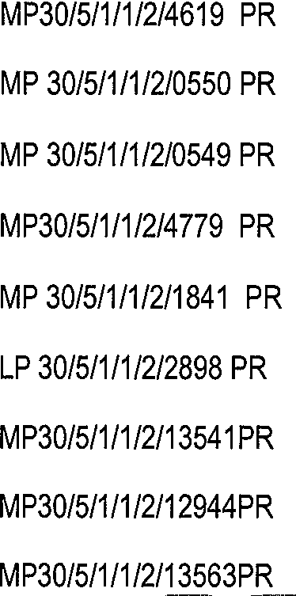MINBTRY OF MINERAL RESOURCES REPUBLIC OF SOUTH AFRICA

Recommended / Not Recommen

 |  | 31,45325341000 | -25,71186871200 | 2009/10/12
 |  | 31,96878494990 | -25,63393733200 | rejected
 |  | 31,81402322220 | -25,68258424200 | rejected
 |  | 31,84108462040 | -25,72258788010 | 2009/10/12
 |  | 31,81658581280 | -25,90235678030 | rejected
 |  | 31,79466917090 | -25,83797900450 | refused no consultation
 |  | 31,82830611450 | -25,64324150990 | refused no consultation
 |  | 31;75612168250 | -25,62375976820 | refused no consultation
MP30/5/1/1/2/13463PR |  | 31,75612168250 | -25,62375976820 | No outcome yet 2015/03/03
 |  | 31,83661113390 | -2563062512550
MP30/5/1/112112928PR |  | 31,96019608670 | -25,67730561270 | 29/10/2014
MP30/5/1/1/2/13183PR |  | 31,81958917440 | -25,74072656330 | rejected
MP30/5/1/1/2/13651PR |  | 31,87511848300 | -25,74720084110 | 4* November 2o014
MP30/5/1/1/2/13549PR |  | 31,80121716950 | -2563720520040 | 2015/06/03
MP30/5/1/1/2/14052PR |  | 31,85030602510 | -25,90690859510 | rejected
MP30/5/1/1/2/15027PR |  | 31,78440680450 | -2563669016420 | 2018/11/06
MP30/5/1/1/2/14884PR |  | 31,92466808080 | -25,72794011510 | lapsed
MP30/5/1/1/2/15634PR |  | 31,48116350740 | -25,70518383400 | NotyetdeGdedon
MP30/5/1/1/2/15993PR |  | 31,92447751970 | -25,92195402590 | Not yet decided on

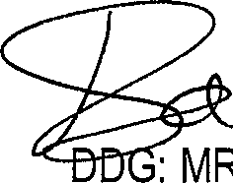
MR
Adv M Malebe

ed

*“<”?'”"”

