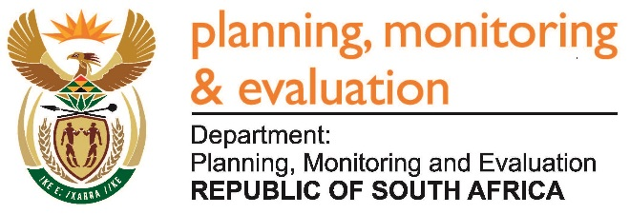 |  | 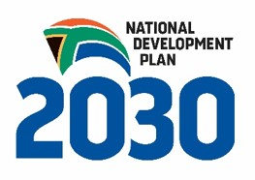
Private Bag X944, PRETORIA, 0001. Union Buildings East Wing, Government Avenue, PRETORIA
Tel: 012 312 0307. www.dpme.gov.za
460. Mr M S F de Freitas (DA) to ask the Minister in The Presidency:
Whether his office procured any services from and/or made any payments to (a) Mr Mzwanele Manyi, (b) the Progressive Professionals Forum, (c) the Decolonisation Fund and/or (d) the Black Business Council; if not, in each case, why not; if so, what (i) services were procured, (ii) was the total cost, (iii) is the detailed breakdown of such costs, (iv) was the total amount paid, (v) was the purpose of the payments and (vi) is the detailed breakdown of such payments in each case? NW516E
Reply:

