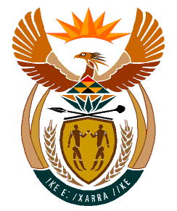

MINISTRY:
HUMAN SETTLEMENTS, WATER AND SANITATION
REPUBLIC OF SOUTH AFRICA

NATIONAL ASSEMBLY

QUESTION FOR WRITTEN REPLY

QUESTION NO.: 46

DATE OF PUBLICATION: 20 JUNE 2019

Ms M S Khawula (EFF) to ask the Minister of Human Settlements, Water and Sanitation:

(a) On what date will the houses of the Msunduzi Local Municipality’s Wirewall Rectification Programme in Phase 4 be completed and (b) why has there been such a long delay in the construction of the houses? NW1003E

REPLY:
- It is anticipated that the houses in the Msunduzi Local Municipality’s Wirewall Rectification Programme in Phase 4 project will be completed by 31 December 2020.

- The KwaZulu-Natal Provincial Department of Human Settlements terminated a contract with the original Service Provider, Masiqhame Trading 376cc in 2013 due to failure to perform in terms of the contractual agreement agreed to. Subsequently, the Msunduzi Local Municipality was instructed by the Provincial Department to procure the services of a new Service Provider to rectify the houses that were not completed by Masiqhame Trading 376cc. A contractual agreement was then entered into between the Msunduzi Local Municipality and the new Service Provider, Farfield Development for the rectification of the outstanding houses and the agreement was signed on 16 May 2016. It then came to the attention of the Local Municipality that some of the houses that were constructed by Masiqhame Trading 376cc were not built in accordance with the layout plan of the area. As a result, a Town Planner was appointed to re-design the project area and amend the zoning of the properties where required.

