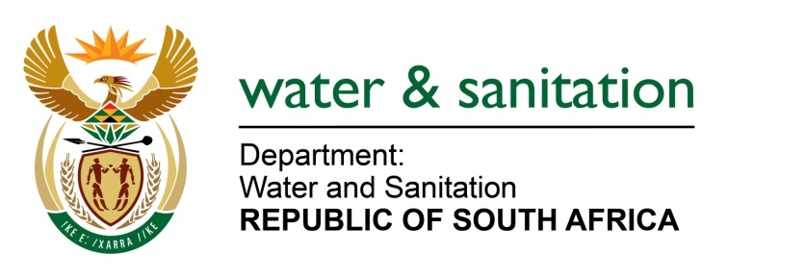

NATIONAL ASSEMBLY

FOR WRITTEN REPLY

QUESTION NO 4595

DATE OF PUBLICATION IN INTERNAL QUESTION PAPER: 25 NOVEMBER 2022
(INTERNAL QUESTION PAPER NO. 50)

4595. Mr. D W Bryant (DA) to ask the Minister of Water and Sanitation:
(1) With reference to Part 9 of the National Water Act, Act 36 of 1998, what measures has his department taken to ensure the compliance of water treatment package plants with their licensing conditions in each province in (a) 2018, (b) 2019, (c) 2020, (d) 2021 and (e) 2022;
(2) what (a) punitive measures have been taken against those who contravened their licence agreements in the specified period in each province and (b) additional measures is his department taking to ensure that privately owned water treatment package plants are licensed and compliant for the period under review in each province?
NW5724E
---00O00---

MINISTER OF WATER AND SANITATION

- Part 9 of the National Water Act, Act 36 of 1998 addresses the review and renewal of licenses, and the amendment and substitution of conditions of licenses. Water treatment package plants, either for drinking water treatment or for wastewater treatment, usually have a design capacity range of between 1-2ML/day. This capacity range is small and has a low impact compared to the conventional larger water treatment plants. Lower-risk water uses are generally authorized through Part 6: Section 39 (General Authorization) of the National Water Act, depending on the sensitivity of the catchment. Licenses are issued for larger treatment plants. The table below provides a summary of regulatory requirements for wastewater treatment and drinking water treatment package plants.

Legal requirements | Wastewater Treatment Package plants | Drinking Water Treatment Package Plants
Water use authorization required | - General Authorization for wastewater discharge.  - Most privately owned plants discharge into the municipal sewer systems and are regulated through Municipal by-laws. | - General Authorization for abstraction  - Storage (where applicable)
Common design Capacity | 1-2Ml/day | 1-2ML/day
Monitoring for compliance | Part of Green Drop | Part of Blue Drop
Mandate | DWS and Water Services Authorities | DWS and Local government as Water Services Authorities
Measures taken by the Department to ensure the compliance of water treatment package plants between 2018 and 2022 include:
- The revival of the Green and Blue Drop certification programs
- Monitoring action plans for non-compliant systems
- Enforcement actions
- Review of the norms and standards for drinking water
- Confirmation of general authorizations for new plants
- As part of the license conditions, package plants are mandated to submit to the DWS, monthly water quality analysis which should be in line with the applicable limits for each parameter analysed.

- (a) The Water Services Act, Act 08 of 1997 does not make provisions for penalties. However, the DWS carries out audits to monitor compliance and implements enforcement actions to rectify contraventions related to non-compliance to the conditions of authorizations.

(b) The Department is monitoring compliance of package plants as provided for by legislation. The department undertakes audits as part of regular monitoring activities and where there is non-compliance, issues Notices or Directives to the owners of the package plant. In some cases, investigations are triggered by reports of suspected cases of non-compliance which are followed up by the department. Where administrative enforcement actions are implemented, the department monitors to ensure full compliance with the conditions of authorisations.
The table below indicates instances where the Department has undertaken compliance monitoring audits and investigations triggered by complaints received and the subsequent administrative actions to address non-compliances.
Table 2: Compliance monitoring audits, inspections conducted, and enforcement actions taken
Activities and administrative action taken | Activities and administrative action taken | Activities and administrative action taken | Activities and administrative action taken | Activities and administrative action taken
2022 | 2021 | 2020 | 2019 | 2018
3x audits and 1x inspection undertaken in Eastern Cape i.e. Mzimvubu / Tsitsikamma | 4x audits and 1x inspection undertaken in Eastern Cape i.e. Mzimvubu / Tsitsikamma | 1x inspection and 2x audits undertaken in Eastern Cape i.e. Mzimvubu / Tsitsikamma | 2x inspections and 1x audit undertaken in Eastern Cape i.e. Mzimvubu / Tsitsikamma | 2x inspections undertaken in Eastern Cape i.e. Mzimvubu / Tsitsikamma
2x Notices issued | 3x Notices issued | 2x Notices issued | 3x Notices issued | 2x Notices issued
- | 3x Directives issued | 1x Directive issued | - | -
Complaints received and investigated
1x complaint received from Limpopo regional office (i.e. Limpopo WMA) | 2x complaints received from North- West and KwaZulu Natal regional office (i.e. Pongola/Mtamvuna and Limpopo WMA) | 3x complaints received from North-West and Limpopo regional office (i.e. Limpopo WMA) | - | -
1x Investigation undertaken | 2x investigations undertaken | 3x investigations undertaken | - | -
1x Notice issued | Both cases were recommended for administrative action | 3x Directives were issued | - | -
---00O00---

