FOR WRITTEN REPLY QUESTION 459

NATIONAL ASSEMBLY
36/1/4/1(201900055)

DATE OF PUBLICATION IN INTERNAL QUESTION PAPER: 1 MARCH 2019 fINTERNAL QUESTION PAPER NO 5-2019)

456. Mr D America (DA) to ask the Minister of Polica:

What number of (a) cases of (i) murder, (ii) rape, (iii) housebreaking, (iv) carjacking,
(v) theft of motor vehicles, (vi) robbery of persons in their houses or on their premises and (vii) drug-related crimes were reported at the Sebenza Police Station,
- such cases were sent to court and (c) convictions were obtained for the specified cases in the past three financial years’2
NW523E
REPLY:
(a)(1)(‹1)(‹1 )(lv)(•)(v›)(via)(b)( )
  - Reported (b) Cases to Court (c) Convictions
Sebenza 2o1s/ 2O1s/ zo1r/ zoo s/ zo‹6/ 2017/ 2015/ 2016/ 2017/
 |  | 2016 | 2017 | 2018 | 2016 | 2017 | 2018 | 2016 | 2017 | 2018
i | Murder | 07 | 00 | 04 | 02 | 00 | 01 | 00 | 00 | 00
li | Rae | 03 | 02 | 05 | 01 | 02 | 03 | 00 | 00 | 00
iii | Housebreakin | 143 | 86 | 95 | 08 | 03 | 05 | 09 | 02 | 03
iv | Car“acking | 17 | 32 | 45 | 02 | 04 | 00 | 01 | 00 | 00

(v) Theft of motor vehicles

98 107 74 02 05 04 00 01 00

(vi) House robbery 36 20 21 06 04 03 06 00 00

Reply to question 459 recommended/

KJ LE (SOEG)

Date: t01t !!"
GENERAL
ER: H AFRICAN POLICE SERVICE

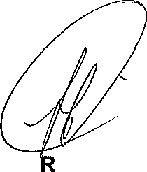
Reply to question 459 approved/cot-approve8-

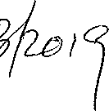
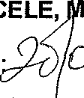
MINISTE’ OF POLICE BH CELE, P

Date

