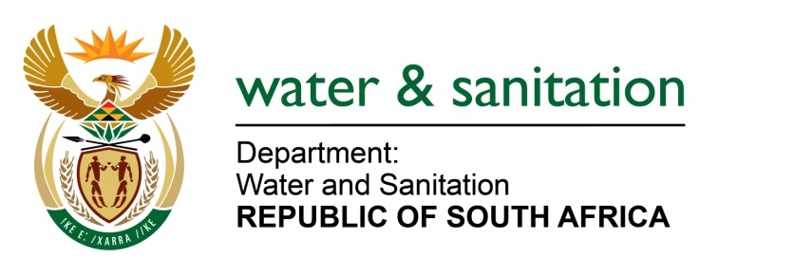

NATIONAL ASSEMBLY

FOR WRITTEN REPLY

QUESTION NO 4589

DATE OF PUBLICATION IN INTERNAL QUESTION PAPER: 25 NOVEMBER 2022
(INTERNAL QUESTION PAPER NO. 50)

4589. Mrs M R Mohlala (EFF) to ask the Minister of Water and Sanitation:
Considering that the total surface water available in the Republic averages about 49 200 million m3 annually, of which about 4 800 million m3 annually originates from the Kingdom of Lesotho, a portion of this runoff known as the Ecological Reserve needs to remain in the river in order to maintain the natural environment along the watercourse, (a)(i) what total amount in water bill does the Republic pay to the Kingdom of Lesotho on annual basis and (ii) which areas benefit more from this water agreement, (b)(i) what is the nature of contract between the Kingdom of Lesotho and the Republic regarding water and (ii) by what date will the contract lapse and (c) what is the Republic doing to ease the burden on the Kingdom of Lesotho such that it is self-sufficient on water?,
NW5718E
---00O00---

MINISTER OF WATER AND SANITATION
a)(i) The allocated budget for royalties for the period 1 Jan to 31 Dec 2022 is R 1 330 million.
(ii) Article 4 of the Treaty describes the purpose as follows: “The Project shall be to enhance the use of water of the Senqu/Orange River by storing, regulating, diverting and controlling the flow of the Senqu/Orange River and its affluents in order to effect the delivery of specified quantities of water to the Designated Outlet Point in the Republic of South Africa and by utilizing such delivery system to generate hydro-electric power in the Kingdom of Lesotho.” The water is transferred into the Vaal River system to mainly supply water users in Gauteng.
- The implementation, operations and commitments to deliver water to South Africa from the Lesotho Highlands Water Project (LHWP) are governed by the Treaty of 1986 and its Protocols and the Phase II Agreement of 2011. The purpose of the Treaty and Agreement is to provide the legal basis for the implementation of Phases I and II of the LHWP as well as for the operation and maintenance of infrastructure.

- There is no date by when the obligations of the Treaty in respect of water deliveries to South Africa will lapse.

- There are extensive programs in place as part of Phases I and II, including:
- Water supply for affected communities
- Sanitation programs for affected communities.
- Releases of water from the LHWP tunnel system for purposes of augmenting the Lesotho Lowlands Water Scheme that delivers water to Maseru and urban areas in the lowlands of Lesotho.
---00O00---

