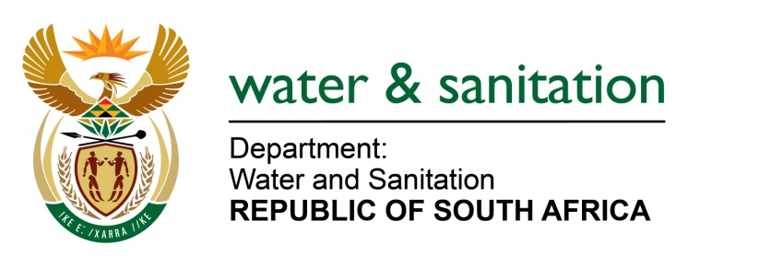

NATIONAL ASSEMBLY

FOR WRITTEN REPLY

QUESTION NO 4588

DATE OF PUBLICATION IN INTERNAL QUESTION PAPER: 25 NOVEMBER 2022
(INTERNAL QUESTION PAPER NO. 50)

4588. Mrs M R Mohlala (EFF) to ask the Minister of Water and Sanitation:
With reference to the estimation that, based on current usage trends, water demand will exceed availability of economically usable fresh water resources in the Republic by 2025, and in view of the fact that the continuing trend in industrialisation and urbanisation of the population is expected to place further pressure on the Republic’s sources of water supply unless appropriate corrective action is taken, (a) what is his department currently doing to ease the pressure as alluded to, (b) what are the key specific workable strategies to deal with the envisaged water demand and (c)(i) which areas will be the most affected when it comes to water demand and (ii) why?
NW5717E
---00O00---

MINISTER OF WATER AND SANITATION

- The Department of Water and Sanitation (DWS) undertakes planning studies over different planning horizons, to develop interventions that are implemented to ensure water security for the country. These interventions comprise of enablers like governance, financing, human capacity building as well as science and innovation which facilitate implementation of water projects at National, Provincial and District and Local Municipality level.

- The interventions implemented to ensure water security are contained in the National Water Resource Strategy (NWRS), through which the minister gives effect to the National Water Act, as well as the National Water and Sanitation Master Plan (NWSMP). Additional interventions include the following:
- Planning and implementing a range of major projects to augment national bulk water resource infrastructure and
- Establishing the National Water Resource Infrastructure Agency (NWRIA) to finance and implement the large-scale investments in national water resource infrastructure that are required to ensure that South Africa has sufficient bulk water supply now and in future.
- The department is prioritising increased but sustainable use of groundwater
- The department is also exploring seawater desalination.
- Strengthening the department’s its role in supporting and intervening in municipalities where water and sanitation services are failing, in conjunction with provinces, COGTA, National Treasury and SALGA.
- The Department is updating the National and sectoral Water Conservation and Water Demand Management strategies. This is to ensure effective performance of WCWDM practices by the sector.
- The DWS has also developed the Water Services Improvement Programme (WSIP) to strengthen its support and intervention at municipal level based on actual data or most available data. The aim of the programme is for the Department to ensure that support and intervention at municipal level is proactive, consistent, and systematic.
- In line with the WSIP, the department has further established the Water Partnership Office (WPO) within the Development Bank of Southern Africa (DBSA). The WPO has developed five standardized National Programmes for private sector participation in municipal water and sanitation services,
- One of the five National Programmes within the WPO is Non- Revenue Water (NRW) programme aimed at implementing the Water Conservation and Water Demand Management and cost recovery programme focusing on reducing losses, reducing over consumption, and improving cost recovery

The various studies that inform the NWRS are available on the DWS website, at http://www6.dwa.gov.za/iwrp/projects.aspx, and the National Water and Sanitation Master Plan (NW&SMP) is available at http://www.dwa.gov.za.

- (i-ii) All provinces are affected by the growing demand for water due to:
- Demand outstripping supply due to extensive growth of urban settlements
- Extension of services to previously serviced rural settlements
- Poor maintenance of ageing infrastructure - at a municipal level - that has also reached the end of its lifespan
- Non-revenue water is currently sitting at 45.1% (31,9 % is losses through physical leakages)
- The management of water treatment plants adds to the crisis as many of the municipal treatment plants are operating below average standards and a third are critical based on the Blue Drop reports.
- Shortage of bulk water (owing to droughts, delayed planning for and delivery of bulk water infrastructure such as dams and associated infrastructure)

---00O00---

