NATIONAL ASSEMBLY
36/1/4/1(201900056)

FOR WRITTEN REPLY

QUESTION 458

DATE OF PUBLICATION IN INTERNAL QUESTION PAPER: 1 MARCH 2019 (INTERNAL QUESTION PAPER NO 5-2019)

458. Mr E J Marals (DA) to ask the Minister of Police:

What number of (a) cases of (i) murder, (ii) rape, (iii) housebreaking, (iv) carjacking,
(v) theft of motor vehicles, (vi) robbery of persons in their houses or on their premises and (vii) drug-related crimes were reported at the Edenvale Police Station,
(b) such cases were sent to court and (c) convictions were obtained for the specified cases in the past three financial years?
NW522E
REPLY:

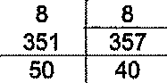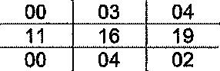(a)(i)(ii)(iii)(iv)(v)(vi)( i)(b)(c)

 |  | Edenvale | (a | Reported | (b) Cases to Court | (c) Convictions
 |  |  | 2o15/ | 017 | 2015 016/ 2 17/ | 2015/ 201 01
 |  |  | 2016 | 2017 2018 | 2016 | 2017 2018 | 2016 } 2017 2018
(i) |  | Murder | 1 | 3 7 | 03 } 00 { 02 | 01 } 00 } 01
(II) |  | Rape | 10 | 8 8 | 00 03 04 | ON0O0 00
(ili |  | Housebreaking | 234 | 351 357 | 11 16 19 | 05 05 02
(iv |  | Carjacking | 5"7 | 50 40 | 00 04 02 | 00 1 02 1 00
(v) |  | Theft of motor  vehicles | 299 | 313 225 | 05 04 05 | 02 02 01
v) |  | House robbery | 73 | 105 93 | 01 ] 07 07 | 04 | 00 } 01
(vii) |  | Drug-related  crimes | 330 | 319 284 | 329 318 283 | 19 78 85

Reply to question 458 recommended/

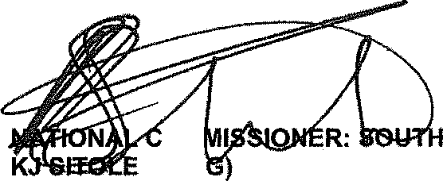GENERAL
OM (SOE
AFRICAN POLICE SERVICE

Date: UTI -f3- 15

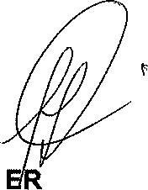
Reply to question 458 approved/not approved

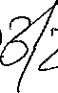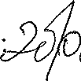MINIST OF POLICE BH CELE, MP

Date:

