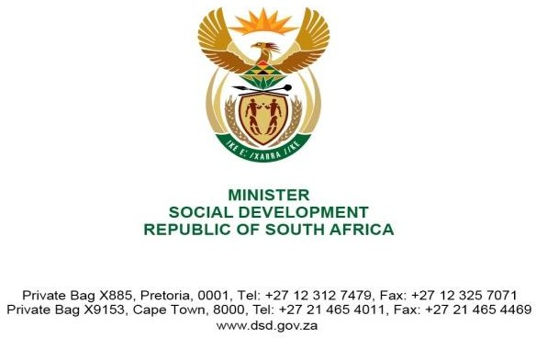

NATIONAL ASSEMBLY QUESTION FOR WRITTEN REPLY QUESTION NUMBER: 4570
DATE OF PUBLICATION IN INTERNAL QUESTION PAPER: 25 NOVEMBER 2022
INTERNAL QUESTION PAPER NUMBER: 50 - 2022

4570. Ms L H Arries (EFF) to ask the Minister of Social Development:

What is the total number of children who have been adopted in the past two years?
NW5699E

REPLY:

The total number of children who have been adopted in the past two years is 1840. Breakdown of adopted children per province in the past two years is as follows:
Province | 2020-2021 | 2021-2022
Gauteng | 268 | 363
Western Cape | 292 | 309
KwaZulu-Natal | 111 | 88
Free State | 47 | 42
Limpopo | 22 | 36
North West | 26 | 27
Eastern Cape | 37 | 82
Northern Cape | 8 | 17
Mpumalanga | 38 | 27
Total | 849 | 991

1

