NATIONAL ASSEMBLY
36/1/4/1(201900057)

FOR WRITTEN REPLY
QUESTION 457
DATE OF PUBLICATION IN INTERNAL QUESTION PAPER: 1 MARCH 2019 (INTERNAL QUESTION PAPER NO 5-2019)

457. Mr E J Marais (DA) to ask the Minister of Police:

What number of (a) cases of (i) murder, (ii) rape, (iii) housebreaking, (iv) carjacking,
(v) theft of motor vehicles, (vi) robbery of persons in their houses or on their premises and (vii) drug-related crimes were reported at the Boksburg Police Station,
(b) such cases were sent to court and (c) convictions were obtained for the specified cases in the past three financial years?
NW521E
REPLY:

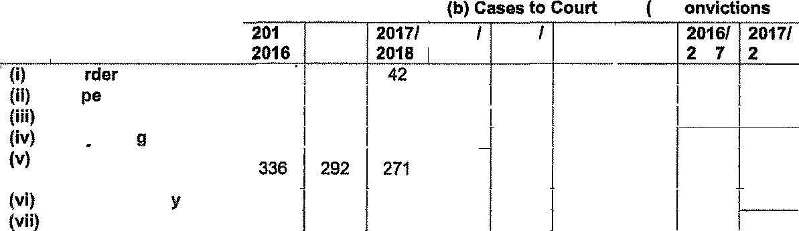
(a)(i)(ii)(iii)(iv)(* )(v i)(vii)(b)( )

 | Mu | Boksburg | (a) Reported |  |  |  |  |  | c) C
 |  |  | 6I | 2016J |  | 2015 | 2016 | 2017/ | 2015/
 |  |  | 2017 |  |  | 2016 | 2017 | 2018 | 2016 | 01 | 018
 |  |  | 42 | 37 |  | 02 | 05 | 08 | 00 | 01 | 00
 | Ra |  | 40 | 45 | 42 | 07 | 15 | 14 | 00 | 04 | 01
 | Housebreaking |  | 547 | 441 | 360 | 02 | 08 | 8 | 00 | 01 | 02
 | Cariackin |  | 37 | 32 | 55 | 04 | 05 | 00 | 00 | 00 | 00
 | Thaft of motor  vehicles |  |  |  |  | 00 | 04 | 05 | 00 | 01 | 01
 | House robber |  | 80 | 72 | 75 | 01 | 06 | 05 | 00 | 00 | 00
 | Drug-related crimes |  | 157 | 145 | 194 | 143 | 192 | 201 | 05 | 06 | 07

Reply to question 457 recommended/

OM E (SOE
GENERAL
H AFRICAN POLICE SERVICE

Reply to question 457 approved/net-apprcrve

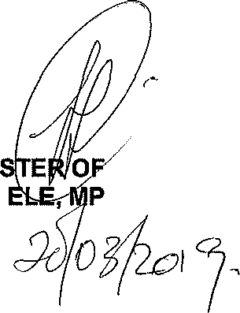
MINI
BH C
Date:
POLICE

