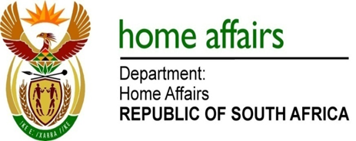

NATIONAL ASSEMBLY

QUESTION FOR WRITTEN REPLY

QUESTION NO. 454

DATE OF PUBLICATION: Friday, 10 March 2017

INTERNAL QUESTION PAPER 9 OF 2017

454. Ms H Bucwa (DA) to ask the Minister of Home Affairs:

Whether his department procured any services from and/or made any payments to (a) Mr Mzwanele Manyi, (b) the Progressive Professionals Forum, (c) the Decolonisation Fund and/or (d) the Black Business Council; if not, in each case, why not; if so, what (i) services were procured, (ii) was the total cost, (iii) is the detailed breakdown of such costs, (iv) was the total amount paid, (v) was the purpose of the payments and (vi) is the detailed breakdown of such payments in each case? NW510E

REPLY:

The Department of Home Affairs has not procured any services from the person or entities listed as there has been no need to do so.

