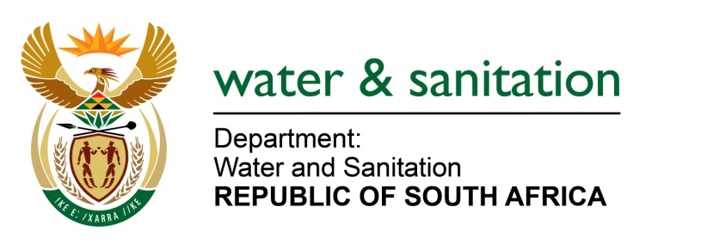

NATIONAL ASSEMBLY

FOR WRITTEN REPLY

QUESTION NO 4533

DATE OF PUBLICATION IN INTERNAL QUESTION PAPER: 25 NOVEMBER 2022
(INTERNAL QUESTION PAPER NO. 50)

4533. Mr K P Sithole (IFP) to ask the Minister of Water and Sanitation:
Whether his department has any alternative plans put in place to provide (a) rural households and (b) persons with disabilities living in rural areas in KwaZulu-Natal with bulk water supply; if not, why not; if so, what are the details of the alternative plans?
NW5662E
---00O00---

MINISTER OF WATER AND SANITATION

The Department of Water and Sanitation is funding various bulk water supply projects which benefit rural househols as well as persons with disabilities in KwaZulu-Natal. The following are the projects which are being implemented in the various municipal areas:

Project name | Municipality | Estimated project cost | No. of beneficiaries | Overall progress
Nongoma BWS | Zululand DM | R822 m | 153 236 | 100%
Greytown BWS | uMzinyathi DM | R523.4 m | 27 824 | 92%
Driefontein BWS | uThukela DM | R536.2 m | 204 306 | 99%
Ngcebo BWS | iLembe DM | R1 096.7 m | 585 900 | 100%
Greater Bulwer BWS | Harry Gwala DM | R339.6 m | 113 256 | 80%
Maphumulo BWS | iLembe DM | R649.9 m | 112 320 | 76%
Mandlakazi BWS Phases 5&6 | Zululand DM | R2 988.0 m | 279 297 | 61%
Middledrift BWS | King Cetshwayo DM | R290.9 m | 177 576 | 54%
Greater Mthonjaneni BWS | King Cetshwayo DM | R2 025.5 m | 99 612 | 65%
Greater Mpofana BWS | UMgungundlovu DM | R954.9 m | 181 590 | 87%
uMshwathi BWS | uMgungundlovu DM & iLembe DM | R2 308.7 m | 362 682 | 50%

