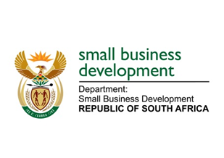
NATIONAL ASSEMBLY

QUESTION FOR WRITTEN REPLY

“453. Ms L L van der Merwe (IFP) to ask the Minister of Small Business Development:

- With reference to the undocumented migrants who trade illegally within the borders of the Republic and her recent statements in this regard, what plans has her department put in place in order to identify all businesses run by undocumented migrants;
- what is the annual contribution of the foreign-owned small businesses to the gross domestic product;
(3) whether she has found reports that the Republic loses R7 billion annually in revenue due to foreign-owned tuck shops that have replaced the spaza shops run by South Africans are a true reflection of the facts; if not, why not; if so, what are the full relevant details?”
NW1443E
REPLY:

- The Department of Small Business Development (DSBD) is participating in the National Joint Operational and Intelligent Structure which comprise of Home Affairs, South Africa Police Service, Intelligent Unit, South African Revenue Service and National Prosecuting Authority, which is aimed at addressing issues relating to undocumented migrants trading in South Africa as well as the production and dealing of illicit goods, among others.
The above mentioned multi stakeholder Task Team is working together with various Local Business Chambers to identify and quantify all businesses that are operated by undocumented migrants. As I announced during my budget vote speech, we are in the process of developing a database / repository of all informal businesses that are operating in South Africa.

- The contribution of foreign-owned small businesses to Gross Domestic Product is unknown as they are part of the undeclared/ informal economy. Additionally, most businesses in the informal sector are unregistered, unlicensed and do not make use of banking and financial institutions. As such, these businesses do not pay tax as well.
As recently witnessed in news reports, some of the goods traded are counterfeit and in the food retail sector; most of the goods sold are not certified by health and other relevant authorities. It is therefore difficult to quantify the contribution of foreign-owned businesses to the local economy.

- Spaza Shops in the Township and Rural Areas have grown to be predominately run by foreign nationals. There has been a decline in the number of South African owned shops due to reasons such as the lack of government support, which we seek to address as the Department of Small Business Development.

