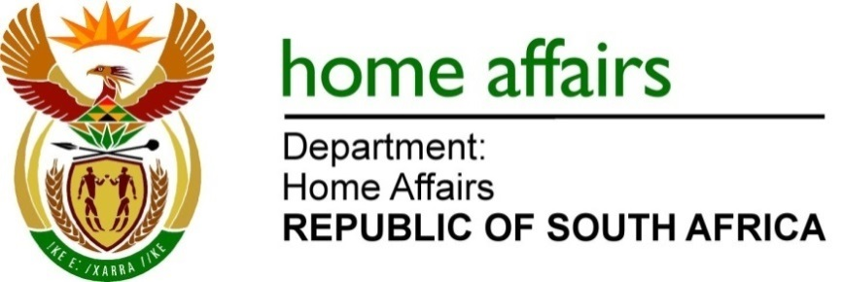
NATIONAL ASSEMBLY

QUESTION FOR WRITTEN REPLY

QUESTION NO. 4526

DATE OF PUBLICATION: FRIDAY, 25 November 2022

INTERNAL QUESTION PAPER 50 – 2022

4526. Mr M Hlengwa (IFP) to ask the Minister of Home Affairs:
Whether, with reference to transactional agreements between individuals in exchange for marriages and identity documents which has caused a rise in identity theft and unknown illegal marriages that he alluded to, his department has taken any steps to also address the oversight and prevent the huge number of individuals who have also been recognised lawfully as married and have unknowingly had their identity stolen by others; if not, why not; if so, (a) what are the relevant details and (b) how has he found it to be possible that his department is failing to adequately provide identity documents to some while individuals find themselves married without their consent? NW5655E

REPLY:
- Yes, the Department has a procedure for dealing with reported fraudulent marriages and identity theft. To elaborate further,it must be highlighted that identity documents theft and fraud, in most cases, does not necessarily involve only the Departmental officials but also the public at large, contractors or service providers, etc., that very well form part of the corrupt activities.
The Department however assists victims of identity theft if the case is reported by the aggrieved or affected persons. Victims should immediately report identity theft through the Law enforcement agencies, mainly the South African Police Services(SAPS) and also the Departments’ Immigration Services Branch to assume investigations and to provide feedback on findings in this regard. Victims can also call the National Anti-Corruption Hotline to report cases of fraud and corruption. Where there is sufficient evidence provided and it can be proven without doubt that the marriage is fraudulent, the Department expunges such a marriage and provides feedback to the victims.
The Department due to the number of fraudulent marriages reported every year has implemented some measures that have largely contributed in reducing the number of fraudulent marriages, as follows:
- Introduction of a new marriage register (DHA-30) which requires a photo and thumbprint of the couples for verification purposes.
- The Department requires prospective couples to make an appointment with the nearest front office to verify the marital status and to subject themselves to brief interviews prior to registration of the marriage.
- On the day of the marriage, a couple must present the following documents to the person officiating at the marriage ceremony:
- Identity documents (for each person getting married).
- If a foreign national is marrying a South African citizen, the non-citizen should present a valid passport as well as well as a completed BI-31 Form (Declaration for the Purpose of Marriage, Letter of no impediment to confirm that he/she is not married in country of origin).
- If the marriage is for a minor (a person under the age of 18 years), written consent is needed in the form of DHA32 by both parents/ legal guardian or form DHA34 from the Commissioner of Child Welfare or a judge. In the case where the marriage is between minors under the ages of 18 for boys or 15 for girls, written consent from the Minister of Home Affairs will also be required.
- If any of the persons who are getting married are divorced, the final decree of divorce should be furnished.
- If any of the persons who are getting married are widowed, the deceased spouse’s death certificate must be submitted.
- No, as indicated above in (a), the Department does not have challenges in providing identity documents to any individuals who found themselves married without their consent or due to identity theft. In terms of the Identification Act. (No. 68 of 1997) the Department provides identity documents to all citizens of the country provided that, their particulars are included in the population register and provided that they apply in the prescribed manner for an identity document.
END

