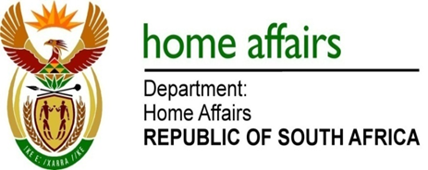

NATIONAL ASSEMBLY

QUESTION FOR WRITTEN REPLY

QUESTION NO. 450

DATE OF PUBLICATION: Friday, 26 February 2016

INTERNAL QUESTION PAPER 4 OF 2016

450. Mrs C Dudley (ACDP) to ask the Minister of Home Affairs:

1) Whether with reference to the urgent plea of a certain mother whose baby had been criminalised after he could not be furnished with the necessary permits (details furnished) he has been made aware of the mother’s urgent plea for assistance; if so,
(2) whether his department has investigated the circumstances of this matter; if so, what are the relevant details; if not,
(3) whether his department will conduct an investigation and assist the mother on a way forward; if not, why not; if so, what are the relevant details? NW504E

REPLY:

(1) I have now been made aware of this matter.
(2) The department has not as yet conducted any investigation.
(3) The department will conduct an investigation into the circumstances surrounding this matter and will inform the client of the outcome.

