NATIONAL ASSEMBLY
36/1/4/1(201900011)

FOR WRITTEN REPLY QUESTION 45
DATE OF PUBLICATION IN INTERNAL QUESTION PAPER: 7 FEBRUARY 2019 (INTERNAL QUESTION PAPER NO 1-2019)

45. Mr M Tshwaku (EFF) to asH the Minister of Police:

What (a) is the number of vacancies in the SA Police Service in each province and
(b) are the details of each vacant position in each province?
NWSOE
REPLY:

The National Commissioner of the South African Police Service (SAPS), recently approved a rationalised organisational structure and is in the process of matching and placing employees, in terms of the structure. As a result, the (a) number of vacancies in the SA Police Service, in each province and (b) details of each vacant position in each province can only be determined after the matching and placing of the employees has been concluded.

Reply to question 45 recommended/

TIQ CO
LE (SOEG)
GENERAL
ER: TH AFRICAN POLICE SERVICE

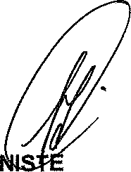
Reply to question 45 approved/

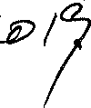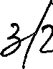MI R OF POLICE BH CELE, MP

Date:

