DATE OF PUBLICATION OF INTERNAL QUESTION PAPER: 25/11/2022
INTERNAL QUESTION PAPER: 50/2022

4490. Mr B B Nodada (DA) to ask the Minister of Basic Education: to ask the Minister of Basic Education:

(1) What is the total number of (a) single-medium schools, (b) double-medium schools and (c) parallel-medium schools (i) nationally and (ii) provincially;
(2) what is the total number of single language of instruction schools for each of the official languages (a) nationally and (b) provincially?
Response
(1)(2)(a)
Table 1 below shows that majority of schools (5 875) are English single medium schools followed by Afrikaans (1 004) single medium schools. With regards to schools that uses African Languages as single medium, majority of schools are IsiXhosa Single Medium.
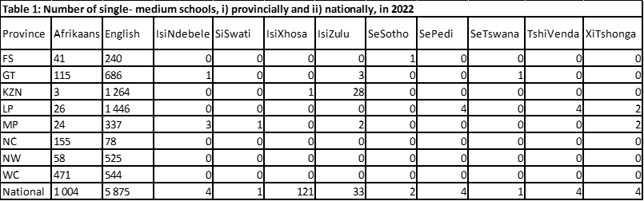
(b) Dual Medium schools are schools that uses two languages of instruction by a teacher in a lesson, switching from one language of instruction to another during a lesson. The Department does not collect information on Dual Medium Schools.
(c)
Table 2 below shows that the majority of parallel-medium schools are found in KwaZulu-Natal (3 807) teaching in IsiZulu and English follwed by the Eastern Cape (3 614) teaching in IsiXhosa and English.
