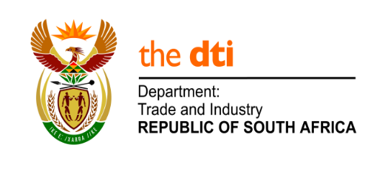
NATIONAL ASSEMBLY

WRITTEN REPLY

PARLIAMENTARY QUESTION 446

DATE OF PUBLICATION: 23 AUGUST 2019
Mr F J Mulder (FF Plus) to ask the Minister of Trade and Industry:
(1) What (a) total amount has been set aside for the Nkomazi Special Economic Zone destined to improve the lives of the communities beyond the southern border of the Kruger National Park in Mpumalanga and (b) are the relevant details of the individual projects that make up the specified amount;
(2) what (a) will his department’s perceived total contribution towards the economic hub be and (b) time frames are envisaged for the project;
(3) whether his department is aware of the proposed mining project on 18 000 hectares of prime property, which is destined to interfere with his department’s plans; if so, what are his departments intentions in this regard;
(4) whether he will make a statement on the matter? NW1436E

Reply

Funding is allocated on approved applications received. In the case of the Nkomazi Special Economic Zone (SEZ), the Province of Mpumalanga is currently establishing an SEZ company to develop, plan and operate the Economic Zone. One of the responsibilities of the entity will be to develop an SEZ implementation plan with clear timelines. The Province has been given twelve (12) months to establish a fully functioning entity. Funding will be allocated on approved applications once this process has been completed.
I have requested the Department to obtain further details about the proposed mining project referred to in the question and will consider the matter once the information has been obtained.

-END-

